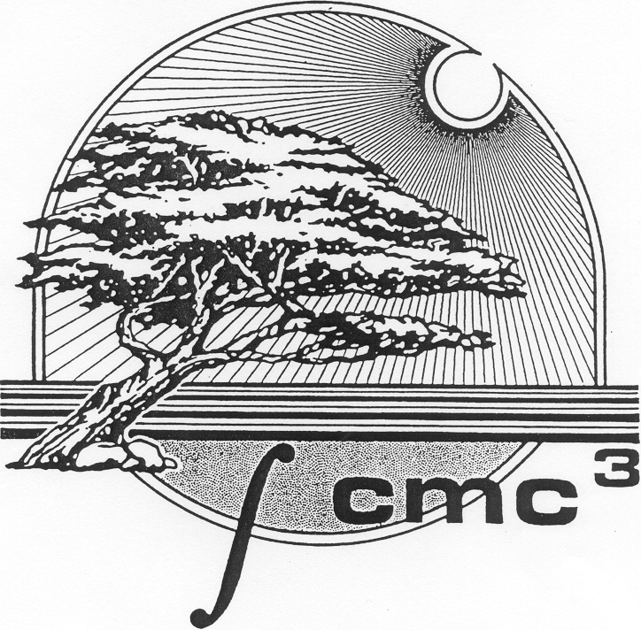
California Mathematics Council,
Community Colleges

Dear CMC³ members,
Like many of you, we have deep concerns about the new piece of legislation AB1705 (Irwin). This bill will have severe negative impacts for the students at our colleges. The proposed legislation doubles down on the more restrictive aspects of AB705, by requiring that colleges eliminate both below transfer level (BTL) placements and enrollments by Fall 2023. The bill presents a “one size fits all” solution to a complex and possibly unsolvable problem. The data that is presented in support of this legislation is incomplete and based on averages, which does not account for the vast diversity of the students we serve not only on a particular college campus, but from college to college. It is too soon to pass additional legislation given that we cannot know the full effect of AB705 after such a short time, especially during this pandemic.
The Board of CMC³ is taking a position against AB1705 for the following reasons:
- The California Community College Mission as provided in the California Education Code is about supporting students in their educational and career goals, not taking away the very choices they need to achieve these goals successfully.
- This legislation will jeopardize financial aid for many students, putting large amounts of pressure on students to pass high unit transfer-level math courses. In the event that a college decides to offer non-credit remedial math courses, financial aid does not cover the cost of those courses. Students are then taking additional units in addition to those required for financial aid, which decreases the time they have to spend on each class. This, in turn, could jeopardize financial aid if students do not pass all of their classes.
- This legislation effectively raises the Community College graduation requirement from Intermediate Algebra or a similarly rigorous Liberal Arts math class to a transfer level math class, potentially putting students who are pursuing a career technical field, such as Fire Science or Nursing, among many others at a grave disadvantage.
- The State of California high school graduation requirement for Math is Algebra 1. Therefore, students who have not completed Algebra 2 in High School, or students returning after a long break, are at a disadvantage when entering college.
- There is little emphasis placed on students from equity populations who wish to pursue a degree in Business, Science, Technology, Engineering, and Math disciplines (BSTEM). There is no opportunity for these students to go back and build a solid foundation in Mathematics which they will need to be successful in courses such as Calculus and Physics.
- In its current form, AB1705 sends a negative message about Career Technical Education (CTE) by stating that the students whose goals do not include transfer must be informed that their coursework does not count towards a baccalaureate degree.
- Mathematics faculty in community colleges across the state should have local control to offer the classes that best meet the needs and demands of their unique communities and student populations.
If you’d like to join us, here are some things you can do.
- Reach out to your Assemblymember and members of the California Assembly HigherEd Committee, including the bill’s author, Assemblymember Irwin to let them know about your concerns with this bill
- Reach out to the Executive Committees of ASCCC and FACCC to let them know that you are concerned with this bill.
- Reach out to student groups in your own colleges, your campus newspaper, as well as members of your community.

On behalf of the CMC³ Board,

James Sullivan (Sierra College)
CMC³ President
Cortney Schultz (Santa Rosa Junior College)
CMC³ President-Elect
Jennifer Carlin-Goldberg (Santa Rosa Junior College)
CMC³ Past-President

