Statewide Default Placement Guidelines
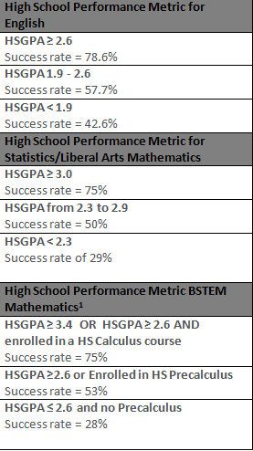

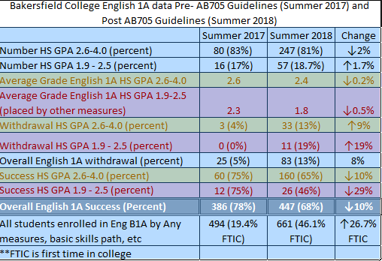
Observations about these data:

Questions:

What data should colleges plan to evaluate?

Predicted probabilities of achieving each of three quantitative competency outcomes for six subsamples of developmental math students, based on estimates derived from logistic regression analyses (not shown)

 |  |  |  |  | Predicted Probability
Subsample | Transfer  Seeking | First Math | Outcome in 1st Attempt of 1st Math | Second Math | Achieving Associate-Level or Transfer-Level Competency | Achieving Transfer-Level Competency | Completing STEM-Track Math Course
1 | Yes |  | Any | Any or None | 0.32 | 0.09 | 0.03
 |  | Intermediate Algebra for Stats | Any | Any or None | 0.34 | 0.24 | 0.02
 |  | Comp/Accel Alg + Int. Alg | Any | Any or None | 0.63 | 0.27 | 0.17
 |  | Intermediate Algebra | Any | Any or None | 0.59 | 0.20 | 0.11
 |  |  |  | N | 1,985 | 1,985 | 1,985
2 | Yes | Algebra | Successful | Any or None | 0.59 | 0.19 | 0.07
 |  | Intermediate Algebra for Stats | Successful | Any or None | 0.51 | 0.38 | 0.04
 |  | Comp/Accel Alg + Int. Alg | Successful | Any or None | 0.70 | 0.37 | 0.24
 |  | Intermediate Algebra | Successful | Any or None | H | 0.44 | 0.23
 |  |  |  | N | 694 | 1,098 | 1,098
3 | Yes | Algebra | Successful | Intermediate Algebra | 0.61 | 0.20 | 0.06
 |  | Intermediate Algebra for Stats | Successful | Math B22 | 0.67 | 0.53 | L
 |  | Intermediate Algebra for Stats | Successful | Psyc B5 | H | 0.88 | L
 |  | Comp/Accel Alg + Int. Alg | Successful | LRNC B530 (Intermediate Algebra) | 0.63 | 0.37 | 0.19
 |  | Intermediate Algebra | Successful | Math B1A | H | 0.65 | 0.61
 |  | Intermediate Algebra | Successful | Math B22 | H | 0.69 | 0.06
 |  | Intermediate Algebra | Successful | Psyc B5 | H | 0.89 | 0.02
 |  |  |  | N | 545 | 840 | 804

Subsample | Transfer  Seeking | First Math | Outcome in 1st Attempt of 1st Math | Second Math | Achieving Associate-Level or Transfer-Level Competency | Achieving Transfer-Level Quantitative Competency | Completing STEM-Track Math Course
4 | No | Algebra | Any | Any or None | 0.38 | 0.08 | 0.05
 |  | Interm. Algebra for Stats | Any | Any or None | 0.08 | 0.11 | L
 |  | Comp/Accel Alg + Int. Alg | Any | Any or None | 0.58 | 0.42 | 0.13
 |  | Interm. Algebra | Any | Any or None | 0.66 | 0.26 | 0.26
 |  |  |  | N | 602 | 578 | 553
5 | No | Algebra | Successful | Any or None | 0.68 | 0.18 | 0.13
 |  | Interm. Algebra for Stats | Successful | Any or None | 0.19 | 0.23 | L
 |  | Comp/Accel Alg + Int. Alg | Successful | Any or None | 0.82 | 0.63 | 0.20
 |  | Interm. Algebra | Successful | Any or None | H | 0.56 | 0.49
 |  |  |  | N | 219 | 294 | 282
6 | No | Algebra | Successful | Interm. Algebra | 0.84 | 0.15 | 0.14
 |  | Interm. Algebra for Stats | Successful | Math B22 | L | L | L
 |  | Interm. Algebra for Stats | Successful | Psyc B5 | H | H | L
 |  | Comp/Accel Alg + Int. Alg | Successful | LRNC B530 (Interm. Algebra ) | 0.88 | 0.61 | 0.13
 |  | Interm. Algebra | Successful | Math B1A | H | 0.81 | 0.89
 |  | Interm. Algebra | Successful | Math B22 | H | 0.58 | 0.19
 |  | Interm. Algebra | Successful | Psyc B5 | H | H | L
 |  |  |  | N | 162 | 202 | 202

Selected outcomes by first math course attempted
 |  |  | % demonstrated associate-level quantitative competency
 | N | % completing quantitative competency | by completing a qualifying non-math course | by completing a qualifying math course | % demonstrated transfer-level competency | Total
Accelerated Arithmetic + Pre-algebra | 1,070 | 15% | 4% | 8% | 3% | 100%
Algebra | 1,435 | 40% | 5% | 23% | 13% | 100%
Algebra for Statistics | 146 | 31% | 8% | 1%** | 22% | 100%
Compressed Accelerated Algebra + Intermediate Algebra | 68 | 69% | 6% | 25% | 38% | 100%
Intermediate Algebra | 938 | 68% | 4% | 34% | 30% | 100%

Distribution of second math course attempted by first math course attempted and outcome in first attempt of first math course, either successful or unsuccessful (transfer-seeking students only)
 |  | Second Math
Successful in 1st Attempt of 1st Math | N | No 2nd Math | Repeat | Algebra | Inter.  Algebra | Accel/Comp  Alg + Int Alg | Pre-Calc | Math Stats | Behavioral Science Stats | Other | Total
Accelerated Arithmetic + Pre-algebra | 376 | 32% | ----- | 53% | ----- | ----- | ----- | ----- | ----- | 15% | 100%
Algebra | 576 | 14% | ----- | ----- | 84% | ----- | ----- | ----- | ----- | 2% | 100%
Algebra for Statistics | 74 | 43% | ----- | ----- | ----- | ----- | ----- | 26% | 23% | 8% | 100%
Comp/ Accel Algebra + Intermediate Algebra | 44 | ----- | ----- | ----- | ----- | 98% | ----- | ----- | ----- | 2% | 100%
Intermediate Algebra | 404 | 28% | ----- | ----- | ----- | ----- | 31% | 28% | 10% | 3% | 100%
Unsuccessful in 1st Attempt of 1st Math | N | No 2nd Math | Repeat | Algebra | Inter.  Algebra | Accel/Comp  Alg + Int Alg | Pre-Calc | Math Stats | Behavioral Science Stats | Other | Total
Accelerated Arithmetic + Pre-algebra | 241 | 74% | 23% | ----- | ----- | ----- | ----- | ----- | ----- | 3% | 100%
Algebra | 475 | 63% | 27% | ----- | ----- | ----- | ----- | ----- | ----- | 11% | 100%
Algebra for Statistics | 45 | 71% | ----- | ----- | ----- | ----- | ----- | ----- | ----- | 29% | 100%
Comp/ Accel Algebra + Intermediate Algebra | 6 | ----- | ----- | ----- | ----- | ----- | ----- | ----- | ----- | 100% | 100%
Intermediate Algebra | 361 | 50% | 42% | ----- | ----- | ----- | ----- | ----- | ----- | 8% | 100%

