Learning to Learn Mathematics - Why is it Critical?
"A Learning Sciences Approach Based upon Process Education Scholarship"
Wade Ellis and Dan Apple
with contributions by: Dave Wilson, Betty Hurley, Matt Watts, Janet Teeguarden, & Dave Kaplan
Abstract
Mathematics Education has been a discipline for at least 150 years, but little research exists on the learning process in mathematics (mathematical learning) and how to teach this process (i.e., Learning to Learn Mathematics). This paper summarizes and expands upon the existing scholarship and practices of Learning to Learn Mathematics as well as introducing key components of new research that will strengthen the teaching of Learning to Learn Mathematics. These components include: 1) the numerous specific risk factors that inhibit learning mathematics; 2) the cultural change focused on Learning to Learn Mathematics that can counteract these risk factors; 3) a model of a mathematical learning process; 4) a model of a mathematical collegiate learner; and 5) measuring and improving mathematical learning capacity. We believe every student will be more successful in learning mathematics if the mathematics education community embraces "Learning to Learn mathematics."
Introduction
This paper focuses on why the mathematics community will want to expand current mathematics educational practices to include learning to learn mathematics. This will help all students learn mathematics better by making a shift in the mathematics educational culture and expanding its set of teaching and learning practices. Learning to Learn has become a significant research area in Process Education and Learning Sciences as documented in "25 Years of Process Education" (Apple, Ellis & Hintze, 2016). This paper will explore many components of Learning to Learn Mathematics research and practice that builds upon the Learning to Learn scholarship.
There are many things that contribute to creating this culture to support Learning to Learn Mathematics. This paper highlights some core evidence-based concepts, skills and practices associated with using learning sciences and Process Education research to address students' and society's disenchantment with mathematics and its culture ("I Hate Math") and incoming students' inability to learn mathematics. The following conceptual framework presented in Figure 1 provides how each of the areas connect and learning to learn mathematics can be implemented.

Figure 1. Conceptual Framework for Learning to Learn Mathematics

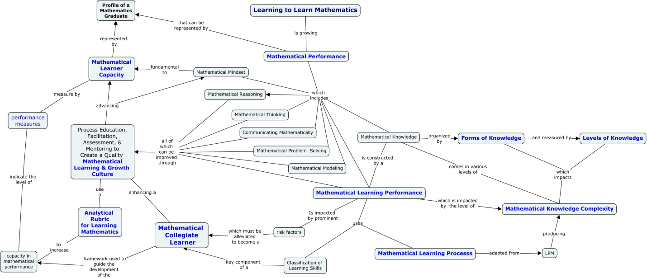

Premises
The conceptual framework in Figure 1, has many components that are built upon a set of key premises arise from the Learning to Learn scholarship. The most important of these premises are presented and discussed to increase understanding of the conceptual framework and the key models presented to enhance the implementation of learning to learn mathematics.
Forms of Knowledge
The definition of knowledge from a Process Education perspective includes both breadth and depth. Breadth is indicated by six forms of knowledge: concepts, processes, tools, contexts, "ways-of-being", and rules (Quarless, 2007). The depth is described in the next section with levels of knowledge. This concept is important to mathematical learning since mathematical knowledge is complex and provides a significant learning challenge for just about everyone. The alignment of the learning experience (includes: activity design, facilitation, and the act of learning) to its knowledge form makes it much more accessible for all levels of learners. Table 1 provides five examples of each form of knowledge in mathematics. The knowledge table provides a useful tool for a systematic approach to the analysis of knowledge.
Table 1. Mathematical Knowledge organized by Forms of Knowledge
Concepts | Processes | Tools | Contexts | Ways of Being | Rules
Equivalency | Solving an equation | Precise definitions | Algebraic problems | Persistence | Order of Operations
Rate of change | Using the mean value theorem | Graphical representation | Geometric investigations | Seeking counter examples | Subscripting
Definite integral | Problem solving | Equation | Probabilistic situations | Proving something true | Order pairs
Equality | Mathematical thinking | Function | Financial analysis | Validating | Implicit coefficients
Derivative | Graphing a function | Matrix | Scientific research | Conjecturing | Function notation

Levels of Knowledge

The five levels of learner knowledge are adapted from Bloom’s taxonomy and were transformed to align with the Learning Process Methodology so these levels can be observed in the college classroom (Bobrowski, 2007). Information acquisition occupies the lowest level and is typified by memorization of information. Conceptual understanding represents the next higher level and is the result of combining informational elements to achieve understanding and meaning. Application is the ability to apply knowledge in a new context. Working expertise (level 4) is the ability to apply knowledge in problem solving situations without the support of outside experts. Level 5 is the ability to create novel discoveries and products through research and creative endeavors.

Generalized Transferable Knowledge
Generalized, transferable knowledge is the ability, without external prompting, to transfer appropriate knowledge productively to problem solving situations or future learning opportunities. The critical steps in producing this generalized transferable knowledge are found in the methodology Elevating Knowledge from Level 1 to Level 3 (Nygren, 2007). Nygren illustrates stages in the development of generalized transferable knowledge with his table, Levels of Knowledge Across Knowledge Forms, where comprehension and understanding are seen as a crucial stage in the learning process and is a prerequisite for being able to contextualize, generalize, and transfer this knowledge. The following are characteristics of such knowledge: you can 1) transfer to new contexts; 2) synthesize with previous knowledge; 3) clarify boundaries; 4) use principles within underlying theory; 5) internalize; 6) explore possibilities for use; 7) adapt as necessary; 8) respond to subtle contextual prompts for use; 9) harmonize its theory with its practice; and 10) effectively communicate this knowledge to others.
Learning Rate and Accumulated Knowledge in a Learning Performance
The following definitions assume that the functions are multivariate with time (t) as an important variable. The variable t is the only variable that varies at a specific point in time. The Learning rate function (L) is dependent only on the change in t (as t varies, say, over an hour) as the other variables (Learner Characteristics included in the Profile of a Quality Mathematics Collegiate Learner) are assumed to be essentially constant over the hour observed. L is the Learning rate function and K is the Knowledge function, from a fixed point (similar to the distance function). The accumulation of the learning rate function (the definite integral of the rate over a time interval) is the total knowledge accumulated (depth and breadth) over that time period (the change in K over the time period).
For example, if the time interval is 0 to 9 minutes, then the following diagrams indicate the relationships. Here the K function is on the left and K(0)=5 and K(9)=41 (units of knowledge). We are assuming the learner characteristics do not change measurably (are constant) over the 9 minutes of the learning performance.
An analogy
Distance (Knowledge accumulated)
Velocity (current learning performance)
Acceleration (change in learning performance – i.e., learning to learn)
K= mathematical knowledge
L = mathematical learning capacity or rate of change of mathematical knowledge

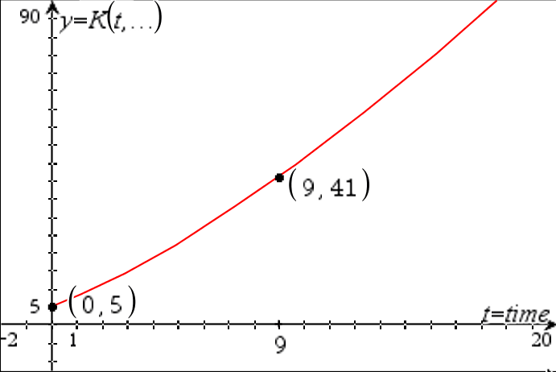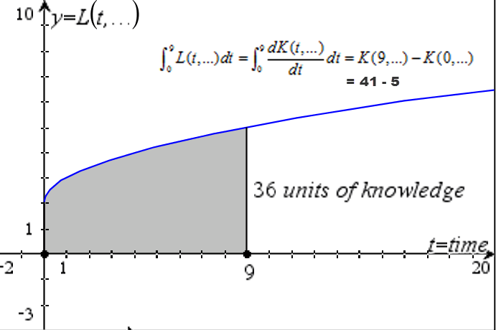
Effective Learning Process is Necessary (but Not Sufficient) for Effective Problem Solving
A critical component of problem solving process is appropriate, active, generalized, and transferable knowledge – the kind of knowledge produced by an effective learning process. As advances in scholarship were presented and discussed at the Problem Solving Across the Curriculum conferences (1990-1996), two insights emerged: educators and learners understood very little about learning process and that quality learning process was critical to becoming a strong problem solver (Apple & Hurley, 1994). Bloom’s Taxonomy (levels of learning) measures the strength of knowledge constructed from a learning process; and, until the learner reaches level 4 (or at a minimum of high level 3), this knowledge will be minimally effective within a problem solving process (Apple, Nygren, Williams, and Litynski, 2002). Nygren in Developing Working Expertise (2007a) discusses the importance of generalized, transferable knowledge in developing expertise.
The insights about the connection between learning and problem solving led the Process Education community to focus efforts on developing the scholarship and practices of learning to learn (Apple, Ellis & Hintze, 2016). Only recently have efforts been focused on the need for students to develop the ability to generalize knowledge so that it can be transferred as the bridge from application (level 3) to problem solving expertise (level 4). Because of these efforts, major advancements occurred in developing learner performances by strengthening classroom facilitation techniques, the use of active learning, activity design, the use of the Learning Process Methodology (LPM), the integration of the classification of learning skills, and the extensive use of assessment, self-assessment and the Process Education philosophy. This strengthening of learner performance led to advancements in the teaching of Problem Solving by connecting the LPM with the Problem Solving Methodology (Apple, Ellis, & Hintze, 2016) and Developing Working Expertise (Nygren, 2007).

The Role of Methodologies in Mathematical Learning and Problem Solving

A quality methodology is an abstract generalization of process knowledge produced by an expert who has years of experience using the process across numerous contexts. Such a methodology allows learners to critically analyze every step in the process to understand its importance in performing the process. A methodology can be used to identify which learning skills are most critical to implementing the process. Methodologies also provide a powerful framework for both assessing the performance and designing performance measures (Apple, Ellis, & Hintze, 2016). The methodologies help to show the differences and connections between different processes, especially processes dependent upon or closely related to each other (such as learning and problem solving). A major example of this kind of analysis can be explored by comparing the purposes, outcomes, and steps in three very important processes: problem solving, design, and research (Cordon & Williams, 2007). Although a methodology to create methodologies was developed (Smith & Apple, 2007), most methodologies can be created and designed by using the Problem Solving Methodology. The use of methodologies in assessing a learner's performance and providing feedback to develop their learning skills increases meta-cognition and contributes to the development of several important of mathematics learner characteristics.
Key Definitions
This paper uses the following definitions of 9 key concepts or ideas, along with the above premises, to articulate the scholarship and practices associated with Learning to Learn mathematics. These definitions and metrics will assist readers in understanding the Conceptual Framework for Learning to Learn Mathematics illustrated in Figure 1 and comprehending the literature review (Appendix A).
Analytical Rubric for Learning Mathematics
This rubric is a tool for measuring and assessing mathematical learning performance. It is adapted from the merger of an analytical rubric for measuring levels of capacity in a Quality Collegiate Learner with an assessment tool for providing feedback on a mathematical learning performance.

Classification of Learning Skills (CLS)
The CLS (Apple, Beyerlein, Leise & Baehr, 2007) is a framework for organizing the key processes and skills fundamental to learning. This valuable tool was designed to help faculty and students identify key learning skills during a learning performance to guide assessment and self-assessment for the purpose of improving future learning performance. The Classification of Learning Skills for Educational Enrichment and Assessment (CLS) represents a 20- year research effort by a team of process educators who created this resource to assist with the holistic development of their students.

Mathematical Learning and Growth Culture
This model of a new mathematical educational culture is an adaptation of the Transformation of Education and provides a framework for understanding and responding to both internal (largely academic and pedagogical) and external (largely economic and cultural) pressures for positive transformation in mathematical teaching and learning. The fourteen aspects of a changing educational culture described in the Transformation of Education are remapped, labeled, defined, and characterized in terms of historical tendencies and future directions that hold promise for better fulfillment of society’s expectations and needs for implementing Learning to Learn Mathematics.

Mathematical Knowledge Complexity (What is it?)
The complexity of a mathematical knowledge item can be analyzed with respect to the levels of complexity in each of the following dimensions: symbolic language, mathematical notation, mathematical objects, mathematical structures, mathematical statements, number systems, use of required mathematical tools and level of abstraction.

Mathematical Knowledge Complexity
The level of complexity of mathematical knowledge is based on each of the following dimensions: symbolic language, mathematical notation, mathematical objects, mathematical structures, mathematical statements, number systems, use of required mathematical tools and level of abstraction. It measures the difficulty students have in absorbing a knowledge area or item.

Mathematical Learner Capacity
Mathematical learner capacity is the ability to engage in the quantitative work of others, construct generalized transferable mathematical knowledge, or effectively solve quantitative problems. It combines both mastery of the mathematical learning process with the acquisition of the dispositions of the mathematical professional including characteristics like validating one's work, identifying issues, modeling situations, and solving problems. Mathematical learning capacity, the internal capacity of a specific learner of mathematics, is measured by the strength in their set of processes, learning skills and dispositions required during the interpretation of others' mathematics, mathematical learning, or the use of mathematics to solve problems.

Mathematical Learning
Mathematical Learning is the process used to construct mathematical knowledge moving from Level 1 (Informational Knowledge) to Level 2 (Knowledge that is understood and has meaning, i.e., can be explained to others or used to teach someone else) to Level 3 (Apply this understanding to a new context) to Level 4 (Generalized knowledge that can easily be transferred within one's working expertise to solve problems, apply it to a new learning challenge, or even applying it to a research effort).

Mathematical Learning Performance
Theory of performance applied to mathematical learning has five components that impact each specific mathematical learning challenge:
- the identity of the learner (e.g. their confidence, ownership, self-efficacy, positive nature, etc.);
- the strength of the learning skills critical for mathematical learning (e.g., recognizing patterns, analyzing similarities, analyzing differences, abstracting, inquiry, contextualizing, generalizing, persisting, validating, managing frustration, etc.);
- the level of current knowledge of mathematics (e.g. prerequisite knowledge, facility with math notation, mathematical terms, connections between big ideas, derivations or proofs, etc.)
- the level of experience in the context/field of that specific mathematical learning challenge (e.g. algebra, geometry, calculus, analysis, statistical, discrete math, etc.)
- any personal factors inhibiting performance in particular ways (e.g. math anxiety, visual impairment, ADHD, dyscalculia, etc.)

Mathematical Performance
Within and outside of the mathematics professional community there is a very common view of mathematical performance that can be divided into major areas, such as: mathematical thinking, mathematical reasoning, mathematical learning, communicating mathematically, mathematical modeling, mathematical problem solving, and possessing broad areas of mathematical expertise and tools along with a mathematical mindset.

Profile of a Quality Mathematical Collegiate Learner
The Profile of a Quality Mathematical Collegiate Learner (PQMCL) is a model of the key characteristics that correlate with a successful mathematical learning performance that has been adapted from the Profile of a Quality Collegiate Learner. It characterizes a student who would be successful in any undergraduate program which has an extensive mathematics component.

Mathematics Risk Factors
This section builds upon risk factors research (Horton, 2015) that identified 20 key risk factors common to many, if not most, incoming college students. Twelve of these 20 risk factors most important for learning mathematics are described in Table 2. This set of risk factors identify the barriers that college students face in learning mathematics that put them at risk of failure to achieve their educational and life goals.

Table 2. Risk factors for learning mathematics common to all disciplines (Horton, 2015):
Lacks Self-Discipline | Easily distracted by social situations & opportunities for immediate gratification, putting off critical work and missing deadlines
Afraid of Failure | Shies away from situations where expectation are challenging & the probability of meeting expectations is low
No Sense of  Self-Efficacy | Often feels overwhelmed, powerless, and/or victimized; “There’s nothing I can do to change things” (i.e., I can't learn mathematics)
Unmotivated | Listless and disinterested, finding little meaning in the mathematics being learned
Fixed Mindset | Accepts current performance level as permanent; I will always be a “C-student” in math
Teacher Pleaser | Constantly seeks direction from the teacher in order to know what the teacher wants and then does exactly what the teacher says
Memorizes Instead of Thinking | Sees mathematical knowledge as a set of memorized rote processes/algorithms that with practice can be temporarily retained to be reproduced on exams
Doesn’t Transfer or Generalize Knowledge | Approaches learning new mathematics as a unique challenge and fails to recognize and use prior knowledge because they have not previously generalized the knowledge
Highly Judgmental -Negative of Self | Constantly self-critical, seeing only past mistakes and failures; not focusing on growth or improvement but instead spends time putting themselves down
Minimal Meta-cognitive Awareness | Unaware of one’s own thought process; cannot articulate the process for or approach to learning, making decisions or solving problems
Insecure Public Speakers | Afraid of speaking in public; avoids speaking out in class or sharing mathematical thoughts and ideas because of perceived inadequacy
Unchallenged (bored) | Have not experienced being outside their comfort zone when learning mathematics because most time is spent on repetitive practice rather than performing mathematics

From our years of experience in working with the mathematics education community, we suggest adding the following 8 risk factors for learning mathematics described in Table 3.
Table 3. Additional Risk Factors for Learning Mathematics
Placement in courses | Placement is determined by a set of math knowledge skills rather than ability to learn mathematics leaving students often either bored or overwhelmed
Students' Current Learning Process | Students memorize rote procedures by doing extensive drill and practice homework problems so they can pass the test that has similar problems
Prerequisite Knowledge | Instructors constantly re-teach content from previous courses since students’ declare they don't remember anything that they are asked to recall and use
Reading Mathematics | Most students can't prepare for class by reading their math textbooks, leaving faculty with little choice but to explain this information to the students
Critical Thinking Skills | There is limited ability to understand "Why" a specific step in a procedure works because they have limited mathematical reasoning and thinking skills
Willingness to Struggle | U.S. students either solve a math learning challenge or problem quickly or feel that they aren't smart and quit
Problem Solving Process | Students have minimal experience in solving complex open-ended mathematical problems and lack the generalized knowledge for problem solving process
Misconceptions | Students often have constructed false knowledge that makes effective construction of future accurate knowledge difficult

Transformational Learning through Learning to Learn Camps
The scholarship and practice of learning to learn was advanced in summer learning to learn camps over 20 years (Apple, Ellis & Hintze, 2015). Students’ learning and problem solving performances advanced remarkably as a result of the learning to learn camp experience. Many of these Learning to Learn Camps became very math oriented with a greater focus on learning to learn math.
Learning to Learn Camps
The Learning to Learn Math curriculum used in these Learning to Learn Camps consists of four major resources:
- Learning to Learn - Becoming a Self-grower which has 15 learning experiences that produce a set of 10 key learning outcomes
- Foundations of Algebra - Core set of learning activities for all STEM students
- Math and Graphing Skills - 40 modules of transferable math skills that are prerequisites for all STEM students
- Student Success Toolbox - a set of reflection and self-assessment tools to build develop self-reflective mindset with meta-cognition skills
Learning to Learn Math Camps
Many students come into college, especially into mathematics intensive programs, with a set of risk factors that lead to non-success (Horton, 2015). The Profile of a Quality Collegiate Learner (Apple, Duncan & Ellis, 2016) targets the transformation that must occur if these students are likely to achieve academic success. This paper illustrates how this transformation counteracts these math risk factors in order to achieve this success. During the five years of the NSF funded STEM UP program (students with ACT scores 15-19) at Hinds Community College - Utica Campus, the Learning to Learn Camps evolved into a very strong implementation of learning to learn math. While these Learning to Learn Algebra Camps continued to develop general learner characteristics of a quality collegiate learner, they also developed mathematics learner characteristics paramount for success in STEM. Examples of a few of these special learner characteristics include 1) embracing failure as part of learning math, 2) seeking to know why something works, 3) validating their own learning, 4) communicating mathematically, 5) increasing meta-cognition of their mathematics learning performance, 6) valuing productive struggle, 7) developing self-confidence by leveraging failures, 8) teaching others mathematics, 9) reading mathematics, and 10) building mathematical language and notation.

Ways For Students to Improve Their Learning of Mathematics
With the focus on developing and improving numerous learner characteristics, here are some of the practices used during the camps:
- Setting the expectations that every learner would become a mathematics learner (Learning to Learn) and increase their learning performance by at double
- Students were given a profile of a mathematics learner
- Students became a better self-grower by using self-assessment with the profile
- Math classroom culture: Assessment culture vs. Evaluation culture
- New Methodologies (15 to 20) for learning in mathematics were analyzed, used, and their performance in use assessed
  - LPM
  - Problem Solving
  - Reading for Learning
  - Content specific - e.g. Solving Equations
- Working in teams with defined roles being rotated after each activity - including the critical thinker
- Performance Measures such as Learning Mathematics and Book of Measures
- Coaching of math teachers to help them change student behaviors by changing their practices and behaviors as a teacher.
These Learning to Learn Camps provided the means to advance the change in mathematics education culture, clarify the mathematics learning process, defining the mathematics learning capacity, and how to measure the transformational learning occurring in these students.
Needed Change in the Mathematics Education Culture
The Transformation of Education, modeling the cultural change expected in Process Education and Learning to Learn, gives the basis for the presentation of the recommended shift in the Mathematics Teaching and Learning Culture (Hintze, Beyerlein, Apple & Holmes, 2011) presented in Table 4.

Table 4: Transformation of Education Applied to Learning to Learn Mathematics
Aspect | Red - Traditional | Green - Future Direction | Best Practices from Algebra L2L Camps
Challenge | Students come to class expecting to be provided with information, examples illustrating how to apply this information, and help when they have not been able to do specific homework problems. | Students read the math text book to acquire content information, think critically during class time to produce understanding, and generalize by creating a hard problem to ensure that they know they know. | - Reading Logs for class preparation using the reading methodology for math  - The hardest problem- students create a difficult problem to challenge if they know they know and to generalize
Complexity | Students need to reproduce solutions to test problems very similar to those that they practiced on their homework. | Students will be given different contexts on tests than were practiced on homework as well as some “unbounded” problem challenges. | - Learning Process Methodology adapted for math to design activities and use in class  - Problem Solving Methodology to support documenting the student process
Control | The way time is spent in class is primarily for faculty to condense information from the textbook, model solving problems like those that will be on the homework to get them started, and then work out requested problems students were not able to do from the previous class homework. | Students determine how classroom time is allocated between thinking for understanding, presenting solutions to each other, and “inquiry” as to better ways to approach and attack learning and problem solving in mathematics. | - Faculty asks students to make decisions in the class for its operations and processes  - Students do a mid-term assessment to give feedback on course quality and ways to improve the course
Delivery | Fundamentally, the instructor knows that the best way to "teach" students mathematics is by sharing their own understanding and explanations with learners and then explaining the right way to work through a problem at the board. | Students who prepare before class, spend time in active learning producing understanding and meaning by teaching each other and learn to generalize by using a variety of application contexts. | - Use formal activities from POGIL or created with Process Education guidelines  - The students produce learning journal entries from each activity

Design | Use of a quality math text book or CMS system that structures the content with a natural flow and appropriate chunks for fitting in the typical delivery system. | A course is designed to produce a specific set of content learning outcomes and to increase learner capacity through a set of integrated activities to increase mathematical performance. | - Use of the Course Design Methodology for creating a set of Learning Outcomes and Performance Criteria  - An activities book that support the course design
Efficacy | Most students enter and most likely exit a math course with a sense of "I don't like math" and with little confidence or belief that they will be able to learn math in the future. | The students gain access to a mathematical learning process, improved mathematical learning skills, and an increase in transferable knowledge leading to greater confidence in addressing future mathematical learning challenges. | - Faculty believe in students till students learn to believe in themselves  - By making the environment performance based, the student accomplishments will increase their efficacy
Feedback | Graded exams and reviews of these exams that share how the students could have gotten the accurate answers to the exam problems. | Provide a variety of feedback on different performance tasks to increase students' learning performance by using tools like practice exams, reading logs and self-assessment to help students improve and document their mathematical performance. | - Students provide assessment feedback to each other to strengthen each others' performance  - Students self-assess their performance to increase their future performance and then faculty assess these self-assessments
Measurement | The faculty produce and use an answer key to determine which problems are correct and then give partial credit aligned with the degree of correctness. | A set of performance measures are defined for the course that are used throughout to measure different aspects of mathematical performance, including mathematical reasoning, mathematical thinking, problem solving, etc. | - Analytical rubrics are used to determine current level of performance to provide data for assessment to improve future performance.  - Holistic rubrics are use to track performance over the years of a program
Ownership | Faculty provide a clear set of directions for what they want the students to do for the course, with a special emphasis on homework assignments and the preparation for the math tests. | Students take the reins of the learning process by reading the math textbook, asking questions, thinking critically, constructing meaning, contextualizing the knowledge, and generalizing to the point of knowing they know. | - Students are provided performance criteria to set expectations and are given the freedom to decide how to meet these expectations  - Faculty only intervene on process and not content

Relationship | Faculty share their passion about the discipline and maintain a very professional demeanor in their interactions with students. | Faculty enter the course with a strong belief in the students, make a public commitment to their success, and will match the students' efforts by helping them improve their learning performance. | - Faculty and students share a public commitment to the process and to the success of each student  - Faculty puts learner needs first
Scope of Learning | Focuses on each of the major ideas in the math course from the perspective of their meaning in mathematics. | Explore how each idea discover can impact a variety of disciplines to show how universal these ideas are. | - Problems presented are interdisciplinary  - Justifying the why of a learning experience uses a range of disciplines to show the value of the content
Self-awareness | A focus on the immediate specific tasks, nose to the grindstone, and just get the work done. | A strong interest in increasing meta-cognition by stepping back to figure out how you did something, why you made certain choices and self-assessing to increase future performance. | - Students are asked to use various reflection tools to increase meta-cognition to determine how they do what they do  - Students document performance, and explore ways to improve that performance
Social Orientation | Students are expected to be able to do the math on their own so they can stand on their own two feet when it comes to future challenges. | Students are part of a learning community and experience extensive cooperative learning where students often engage in mathematical learning with others so they can teach each other. | - Students are placed in cooperative learning teams using rotating roles to grow all aspects of learner performance  - Students are part of a learning community where all students support and assess each other to help each other grow and succeed
Transparency | The students spend a lot of their time doing homework problems alone and also take midterm and final exams without anyone observing their mathematical performance. | Students spend their time doing learning activities, faculty facilitating and assessing the teams' learning performance and, during closure, teams are presenting and assessing each other’s work. | - Students perform their critical thinking within teams so that everyone can help elevate their mathematical thinking and reasoning  - Board work is essentially done by the students and not the instructor

Mathematics Learning Process Relationship to the Learning Process Methodology
Mathematics learning is a way of being for mathematical thinkers who use it to build new mathematical understandings and ways of applying mathematics to create more meaning for themselves and for the world. Mathematics learning involves the manipulation of mathematical objects, mathematical statements, different forms of representations and is a precise way of thinking to establish for oneself and the world a consistency of meaning. Mathematics learning process uses the scholarship on Learning Process Methodology (LPM), which has a long history in Process Education literature (Apple, Ellis, Hintze, 2016) and can be reviewed in Table 5.
Table 5. Learning Process Methodology

Step |  | Explanation
Stage 1: Preparing to Learn
1 | Why | Identify and explain your reasons for learning.
2 | Orientation | Develop a systematic overview of what is to be learned.
3 | Prerequisites | Identify necessary skills and background knowledge needed to perform the learning.
4 | Learning Objectives | Set appropriate goals and objectives for the learning activity.
5 | Performance Criteria | Determine specific desired outcomes used to measure and gauge performance.
6 | Vocabulary | Identify and learn key terminology.
7 | Information | Collect, read, and study appropriate resources.
Stage 2: Performing a Learning Activity
8 | Planning | Develop a plan of action to meet the performance criteria.
9 | Using Models | Study and review examples that assist in meeting the learning objectives and performance criteria
10 | Critical Thinking | Pose and answer questions that stimulate thought and promote understanding.
11 | Transferring/Applying | Transfer knowledge to different contexts; apply knowledge in new situations.
12 | Problem Solving | Use knowledge in problem-solving situations.
Stage 3: Assessing and Building New Knowledge
13 | Self-assessment | Assess use of the learning process and mastery of the material learned.
14 | Research | Create and develop knowledge that is new and unique.

Mathematics Learning Process

With 20 years of experience publishing Process Education and POGIL activity books, the Pacific Crest publishing manager, authors, and professional development staff have constantly been advancing its interpretation of the Learning Process Methodology (LPM) in supporting STEM learning process and especially the mathematical learning process. Wade Ellis, the Pacific Crest math editor, revised the LPM authoring guidelines while leading the development of the latest two books: Foundations of Algebra (Ellis, Teeguarden, and Apple, 2013) and Quantitative Reasoning and Problem Solving (Ellis, Apple, Watts, Hintze, Teeguarden, Cappetta, and Burke, 2014). These revised guidelines were used to contextualize the learning process for mathematics in the first chapter of the QRPS book which we titled
Learning to Learn Math. We used this experience, these guidelines and the research presented in our latest papers on Learning to Learn: Improving Learning Performance (Apple & Ellis, 2015) and Key Learner Characteristics for Academic Success (Apple, Duncan & Ellis, 2016) to create the Mathematics Learning Process Methodology (Figure 2). The 15 steps of the Mathematics Learning Process (Table 4) have evolved from the 14 steps of the Learning Process Methodology. This methodology takes on three perspectives - the designer of math activities, the facilitator of math learning experiences and that of the learner constructing their mathematical knowledge.

Figure 2. Mathematics Learning Process (From 3 Perspectives - Designer, Facilitator & Learner)
"with Mapping to the Learning Process Methodology Provided"
Step 1: Purpose (LPM Step 1: why)
- What is going to be learned?
- Why is this knowledge important to the big picture of the course/discipline?
- How does this knowledge connect with other related knowledge? (LPM Step 2: orientation)
- Why is this knowledge relevant to the learner's life?
Step 2: What do we do to approach this learning (essential core) like a mathematician with the
discovery and creativity to make it interesting, intriguing, and fun? (i.e., play with the
mathematics)
- Find an interesting context relevant to the learner(s) (Who Gives Darn?) (Step 1 LPM)
- Make it discovery oriented - (Step 2 LPM: orientation)
- Add creativity and new insights to the discoveries
- Engage in learning that mirrors the mathematical mindset
Step 3: Expectations for the learning performance (LPM Step 4: learning objectives and LPM Step 5: performance criteria)
- What are the learning objectives?
- What are the expected performances, and associated tasks, that the learner must be able to do by the end of the learning experience?
- What are the specific performance criteria that are going to be used for measuring the quality of this performance?
- The description of the expected level of performance should allow the learner or facilitator to determine the degree of success.
Step 4: What do you already know? (LPM Step 3: pre-requisites)
- What previous life experiences can you bring forward to this new learning?
- What previous knowledge of prior courses can you take advantage of?
- What can you bring forward from the discovery exercise?
- What can you look forward to in the current reading that you can utilize?
- What you can look for and analyze in the presented models?

Step 5: Required mathematical language (the precision of its terminology, symbolic representations and mathematical notation) (LPM Step 6: Vocabulary)
- Identify previous mathematical language that is going to be used
- Introduce new symbolic representations and language equivalents
- Introduce new associated tool(s) and mathematical notations/conventions
- Introduce the terminology for each of the new mathematical ideas/concepts
Step 6: Information needed before (reading assignment) and during the learning experience (LPM Step 7: Information)
- Describes briefly the key concepts and big ideas
- Identifies valuable internet sites or books for exploring and reading
- Provides unique resources and expertise for the learning
- Methodologies
  - Steps with discussion
  - Worked out example(s)
  - Opportunity for learner to try out their own example
- Heuristic tables
- Common Errors
- Visuals and diagrams representing unique perspective
Step 7: Learning resources (LPM Step 7 - Information and Resources)
- Data sets
- Software tools
- Learning Objects
- Simulations
- Manipulatives
Step 8: Are you Ready? (LPM Step 8: Plan)
- Validate what is known after performing Mathematics Learning Process Steps 1 -6
- Document this learning with answers to Exploratory Questions and/or reading quiz
- Document what is not known with a set of questions ready to be investigated in class
- Identify the key learning challenges contained within this knowledge
- Planning how the learner will meet the challenges - putting together a plan with specific steps

Step 9: Classroom activity
- Summarize and review Steps 1 - 7 of the LPM
  - Why (step 1 of LPM)
  - Learning Objectives (Step 4 of LPM)
  - Performance and Criteria (Step 5 of LPM)
  - Critical Information for the activity (Step 7 of LPM)
- Plan (Step 8 - LPM) - connects pre-activity of the experience to the classroom experience, including specific tasks such as sub-activities to increase understanding related to CTQ
- Models (Step 9 of LPM)
- Critical Thinking Questions (Step 10 of LPM)
Step 10: Demonstrate Your Understanding (Step 11 of LPM)
- Start with familiar context
- Move into a less familiar context
- Challenge learner to transfer to an unfamiliar context
- Limit the additional challenges to 3 with the focus on generalizing
Step 11: Hardest Problem - Generalizing the knowledge (continuance of Step 11 of LPM)
- Identify the variations that can be included in the problem that would complicate solving it
- Create a problem that challenges all these dimensions
- Think through to make sure that you can address all the dimensions even when they change
- Test the boundary conditions for validity
- Explore possible and appropriate contexts for use of this knowledge based upon valid contextual prompts, issues and boundaries
Step 12: Making it Matter - Problem Solving (Step 12 of LPM)
- Explore situations that require the use of this knowledge along with previous knowledge
- Pick contexts or situations that are meaningful for the learner
- Set the level of challenge presented in the problem to require the use of the problem solving methodology but not so difficult that it would require research process
- Learner must identify meaningful contexts so they can own and solve relevant problems
- Focus on Step 9 of PSM to see how these problem solutions can be reused in new situations
Step 13: Identify and Correct the Errors (Step 13 of LPM - a focus on content)
- Assess the learning - knowing you know what you know
- Shift from nearly clear to crystal clear by finding out others' errors in thinking
- Validate learning by using at least one validation technique

Step 14: Learning to Learn Mathematics (step 13 of LPM - focus on discipline process)
- Target areas of mathematical learning to reflect on
- Explore the way of being of a Mathematician connected with the content
- Identify ways to help the growth of the learner, i.e., improving learning skills
Step 15: Assess Learning Performance (step 13 of LPM - focus on Mathematics Learning Process)
- Use the target of the learning challenge (Performance and Criteria) for self-assessment of effectiveness and efficiency of learning performance
- Recognize strengths produced and how they were produced
- Identify improvements with specific action plans
- Develop new understanding about learning process and learning performance
Mathematical Learner Capacity
Mathematical Learning Capacity (the internal capacity of the learner) is the set of processes, learning skills and dispositions of the learner required during the interpretation, learning, or use of mathematics. The ability to engage in the quantitative work of others, construct generalized transferable mathematical knowledge, or effectively solve quantitative problems, these are essential traits that all productive professionals should possess. Since mathematical learning is a specific type of learning, it shares the same general learning process characteristics derived from learning theory as do all disciplines. Therefore, we can advance students' mathematical learning by leveraging learning theory to address the special attributes associated with learning in mathematics. In addition to the mathematics learning process, the depositions of the mathematical professional (see profile of Mathematics Graduate - Appendix B), which includes characteristics like validating one's work, identifying issues, modeling situations are also important in problem solving.
The Profile of a Quality Mathematical Collegiate Learner (PQMCL) was constructed using a very small change in the Profile of a Quality Collegiate Learner (PQCL) as its foundation (Apple, Duncan & Ellis, 2016). Initially, several mathematics educators were asked to identify which of the 50 PQCL learner characteristics could be omitted without impacting performance in learning mathematics; they consistently found that all were essential thus not a single one could be omitted. Therefore, we concluded that the PQMCL would just be an extension of the PQCL with a slight restructuring of the PQCL (see Appendix C) .
The identification of the additional learner characteristics included in the PQMCL was triggered by the analysis of four different projects:
- Creation of a Profile of a Mathematics Graduate (Appendix B) produced by the Mathematics Department at SUNY Buffalo State in 2013 - it was used to produce a framework for the PQMCL extension and contributed over half of the specific 28 learner characteristics;
- An unpublished analytical rubric (Appendix D) was created in 2000 to be used to assess and improve mathematical learning performance - this contributed five learner characteristics;
- Determining what are the key risk factors associated with learning mathematics - this contributed two learner characteristics;
- The Engineering and Chemistry education communities are producing similar research on extending the PQCL for their disciplines - two more learner characteristics were added.

Finally, stepping back and reviewing years of observing and describing the mindset of mathematicians, another learner characteristic was added: [mathematicians] Enjoy Productive Struggle. The extension of the PQMCL, its learner characteristics and their descriptions are presented in Table 6.
Measuring Mathematical Learner Capacity
Process Education research in the areas of theory of performance, performance criteria and performance measures (Apple, Ellis & Hintze, 2016) has led to the idea that learner capacity can be defined (PQMCL) and measured. The performance measure for PQMCL builds upon the unpublished scholarship of the performance measure for a QCL (Appendix C) and then is expanded to incorporate the additional 28 learner characteristics located in Table 6 and this expanded measure is presented in Table 7.
Conclusions
The research based on recovery courses (http://pcrest.com/recovery/) for 1st year students who are being academically dismissed has reinforced the literature around STEM attrition (Chen, 2013), that is the math courses being a critical barrier to student academic success. The STEM attrition report found that 40% of the 2,000,000 STEM declared majors in 2004/2005 cohort did not receive collegiate math credit during their first year, which implied that while most students took a math course, they did not pass it. A Learning to Learn Math intervention with all students who fail a math course could significantly advance this research. This effort would illustrate how you can transform the current situation where most students don't recover to complete their math sequence (56% attrition of the declared STEM majors) to a situation where most students do recover to complete their math sequence. The STEM pipeline would vastly improve with this one meaningful intervention - Learning to Learn Mathematics. Over the next few years we will be advancing the professional development for teaching Learning to Learn, building curriculum focusing on a Learning to Learn Math Recovery course as well as and a co-requisite math course, implementing Learning to Learn Math Recovery Camps, measuring the growth in math learner capacity of these students and collecting research data on how these learners perform in future math courses.

Table 6. Profile of A Quality Mathematical Collegiate Learner Extension
Mathematical Mindset
Skeptical | Thoroughly checks validity of newly presented material using mathematical and logical tools
Precise | Meticulous; rechecks thinking; selects best phrasing and notation; seeks maximal accuracy
Productive struggle | Loves uncovering solutions to impossible barriers through exhaustive reflective thought
Self-reliant | Performs complex mathematical tasks without assistance relying on their own thinking process
Mathematical Reasoning
Makes conjectures | Induces generalizations that can be tested; seeks to organize knowledge into structures
Counter examples | Tests new conjectures or generalizations to see if they can stand up to refuting examples
Logical | Tests validity of ideas, conjectures, proofs, or constructions against rules of inference
Rules out paths | Identifies non-productive paths or approaches quickly
Mathematical Thinking
Abstract | Moves nimbly from concrete to symbolic; facile with complex notation, statements & structures
Visualize | Skilled using pictures, diagrams, and graphs to explore mathematical ideas, structures, or models
Representations | Explores mathematics ideas using numerical, graphical, symbolic, or other representations
Makes connections | Finds the relationships between existing and newly constructed concepts or areas of knowledge
Mathematical Modeling
Builds models | Develops concise mathematical relationships that quantitatively describe real-world phenomena
Tool usage | Identifies tools to improve mathematical efficiency and quickly becomes adept using them
Innovates | Constructs novel approaches by refining existing pathways, synthesizing or developing new ones
Interprets data | Utilizes number sense and facility with structures to transform, analyze, and present data
Mathematical Learning
Interprets notation | Quickly understands and works with unfamiliar symbolic formats and supporting conventions
Uses examples | Selects cases to build conceptual understanding that elucidate distinctions and generalizations
Thinks analytically | Parses situations into their essentials to reveal clarity in the details being examined
Transfers knowledge | Applies mathematical meaning to areas where it had not previously been applied
Mathematical Problem Solving
Defines problems | Envisions and frames situations leading to clarity in understanding what needs to be resolved
Identifies key issues | Determines key questions in complex situations or problems that need to be tackled
Reuses solutions | Employs tried and true methods - or extends them as needed - to solve problems
Notices Assumptions | Recognizes critical suppositions that validity of eventual solutions will depend on
Communicating Mathematically
Uses math language | Properly employs formal mathematical terms, phrases and notation fluently
Translates | Transforms mathematical symbols and terminology into simple, easily-understood language
Teaches | Clarifies the mathematics to help others increase their understanding of potential implications
Thinks quickly | Alacrity with involved computations, complex inquiries, & responding to unexpected challenges

Math learner  characteristic | Trained:  survival learners | Learned:  need-based learners | Learners:  contained learners | Enhanced Learners:  professional | Self-growers:  pioneer learners
Mindset | As taught | When prompted | When useful | Conscious integration | Intrinsic integration
Skeptical | Often accepting | Accepts experts | Questions inexperienced | Until fully convinced | Questions even self
Precise | Lay-level accuracy | Somewhat accurate | Working-level accuracy | Polished accurate work | Removes ambiguities
Productive struggle | Easy solutions | Known approaches | When In expertise area | When gain is great | Process 1st, results 2nd
Self-reliant | Minimally | In simple practice | In areas of confidence | In areas of responsibility | When others have failed
Reasoning | One-step arguments | Basic arguments | Complex arguments | Proves theorems | Creates mathematics
Makes conjectures | When forced to | In areas of interest | In area of expertise | All daily life challenges | Ground-breaking areas
Counter examples | When pointed out | Detects weak premises | Most issues challenged | Rarely fail to find | Challenges conventions
Logical | Frequent logic errors | No basic logical errors | Errors in intricate cases | Very rarely makes errors | Sees errors others miss
Rules out paths | Sees when pointed out | Sees obvious dead ends | Sees common dead ends | Sees most dead ends | Sees unseen dead ends
Thinking | Memorizes | Follows explanations | Analyzes | Elevates Understanding | Integrates expertise
Abstract | Needs concrete cases | For basic abstractions | When needed to think | To enhance thinking | Develops abstractions
Visualize | When obvious | Sees object in context | Sees object & contexts | Sees changing context | Paints pictures for all
Representations | The one and only | Illustrated alternatives | When confused | To increase richness | Continually varies
Makes connections | Only if fully elucidated | Obvious ones | Many connections made | Develops concept maps | Multi-level and visionary
Modeling | Concrete only | Uses other's models | Develops basic models | Advancing models | Develops new models
Builds models | Only uses tangible | Uses diagrams & images | Builds math models | Applicable new models | Innovative new models
Tool usage | Tool use w/ guidance | Common-use tools | Recommended tools | Comprehensive tool set | Extends, develops tools
Innovates | If nothing else works | In areas of keen interest | In professional expertise | When productivity stalls | Continuously
Interprets data | When essential | In commonly seen cases | To answer inquiries | To give insights | To broaden perspective
Learning | Regurgitate as given | Can explain basics | Can teach others | Can generalize | Expertise and extension
Interprets notation | Only after explained | As used commonly | Across most math fields | In new situations | Creates new notation
Uses examples | Uses when explained | Readily available | Creates simple examples | Plays with & modifies | Develops to test bounds
Thinks analytically | Sees obvious, if shown | Some distinctions | Sees details | Can explain details | Sees how to extend
Transfers knowledge | To same case | To cases practiced | To analogous cases | To new applications | To widely-varied cases
Problem Solving | Formulaic problems | Complex exercises | Uses PS methodology | Real world problems | W/in & interdisciplinary
Identifies problems | If others point it out | In area of concern | In common situations | Reveals target | Gain consensus
Identifies key issues | The most obvious | Many key | Most key | Ranked list | Includes unforeseen
Reuse Solutions | Mostly one time use | Very frequent problems | Most common problems | For most sub-solutions | Generalizes solution
Notices Assumptions | Perhaps, if challenged | Critical ones | Most used | For perceived use | For future uses also
Communication | Often vague | Basic math language | Translates for audience | Explain math reasoning | Educates audience
Vocabulary builder | Only if needed | Functional usage | Versed | To share ideas | To develop ideas
Translator | Struggles to be clear | Not always understood | Makes basics clear | Clarifies all details | Clarifies big picture
Teacher | Re-explains basics | Teaches as taught | Develops understanding | Develops math learners | Develops self-growers
Quick-thinking | Struggles with basics | In scripted situations | In expertise areas only | In professional discourse | In any situation
Table 7. Measuring Mathematics Collegiate Learners' Performance
Appendix B
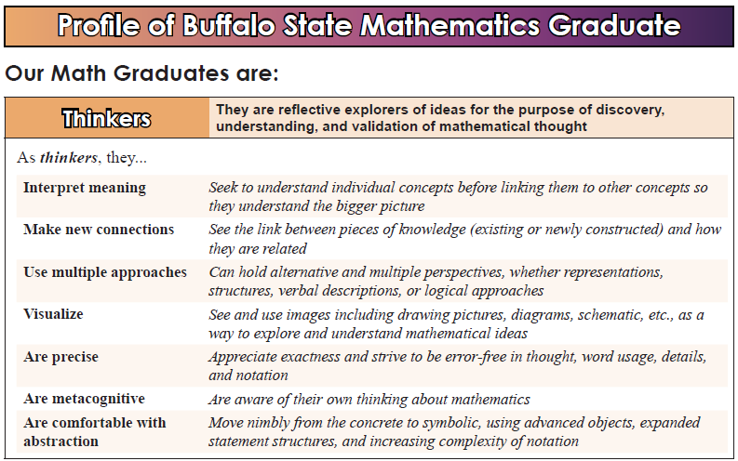
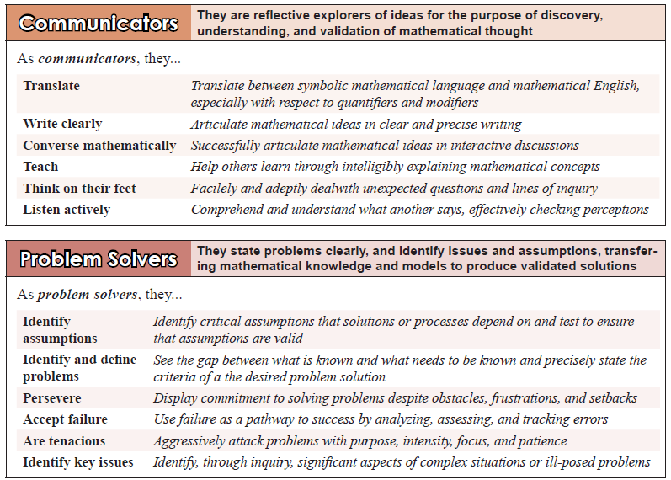

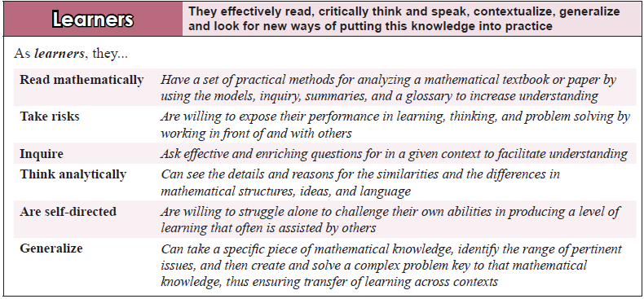
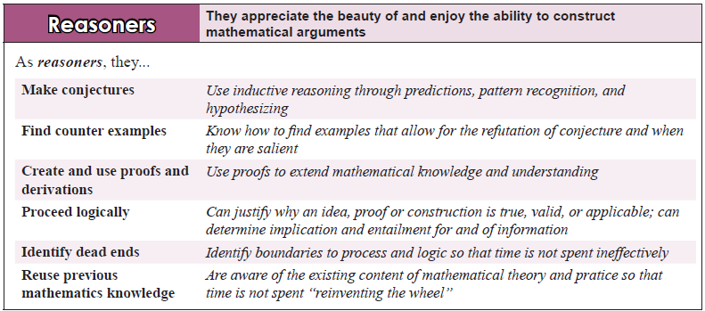
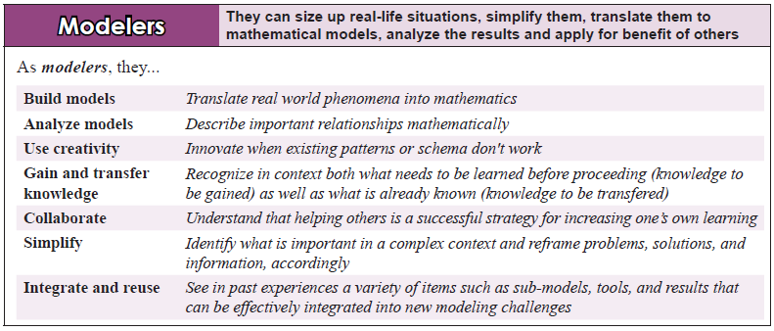
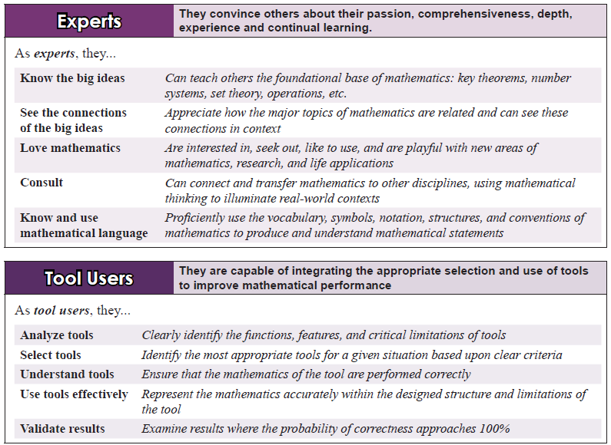
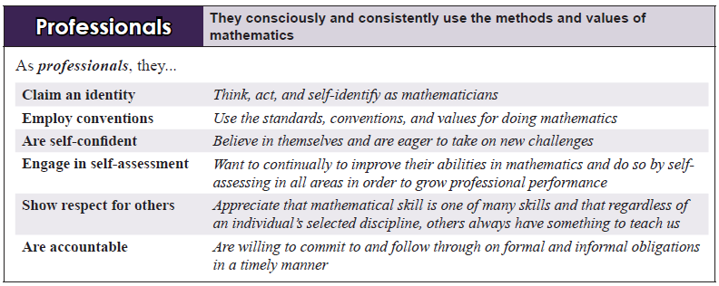

Appendix C: Performance Measure for a Collegiate Learner (Work in Progress)
Description
Collegiate learners are master learners who are focused, highly motivated, responsible, and take ownership of their own learning process. They are committed to their success towards their life vision through hard work, persistence, and self-efficacy. They seek challenges to work on self-growth by taking risks to get outside their comfort zone, embracing failures, seeking feedback and using self-assessment. In each of their efforts they are prepared, actively engage, and collaborate within and outside learning experiences by communicating, asking questions, thinking critically and sharing insights publicly and in writing. They effectively plan to manage their time and resources and are disciplined in carrying out their plans. They are positive and intellectually curious, supporting others in team learning. They apply their learning in new contexts by using higher order thinking to contextualize and generalize their knowledge to solve complex problems.
Dimensions
Collegiate Learners are:
Master Learners: Who take ownership for their learning by identifying its purpose, objectives, and performance criteria, analyze information and models by asking critical questions, synthesizes meaning, elevate understanding, explore and apply this advanced understanding to multiple contexts, and finally through meta-cognition generalize this knowledge to any context.
Self-Development Oriented (Growth Mindset): Who have developed a strong belief in their current capacity and with this develop a very positive and open-minded attitude towards increasing future capacity, and with feedback from others, consistent reflection and self-assessment improves their future capacity.
Academically Oriented (Have a Academic Mindset): Who established and documented academic and life goals aligned to their life vision and consistently use resources to clarify expectations and understanding through formulating effective inquiry questions.
Academically Productive: by coming prepared to each performance and getting organized, initiating action by putting themselves fully into the challenge and keeping focused on what needs to happen.
Learning Process Oriented: who study, analyze, improve their use of methodologies for information processing, reading, writing, problem solving, and reflecting to keep improving their performance in these critical process areas that support the learning process.
Versed in Learning Strategies: that start with effective learning plans, assertion of themselves into the middle of the learning opportunity, and through collaboration of others and hard work continue the learning till the planned outcomes are self-validated.
Outside their Comfort Zone: by taking risks, embracing failure as a frequent and productive road to success, leveraging these failures for growth, and with balance and wellness have the strength to persist till this success and growth are realized thus are willing to self-challenge themselves even more outside the comfort zone.
Emotionally Intelligent: and adapt effectively to new situations, manage their frustrations and anxiety, manage their time productively, prioritize by do important things first, and when road blocks prevent progress ask for help.
Socially Integrated: who are well connected, partnering with diverse people, performing team roles effectively, conversing, listening actively and speaking out publicly.
Professionals: who are disciplined in following their plans, motivated by their passion to make a difference, confident in their actions, thus taking the responsibility to succeed by their extensive commitment to exceed internal and external expectations.
Holistic Rubric - Measuring the Level of Quality of Collegiate Learner
Self-growers (Pioneer Learners)
- are consistently improving performance daily with every experience by constantly learning and elevating knowledge.
- love colleges and all they represent, participate in as many of its challenges, and thrive in pursuit and sharing of new knowledge.
- have modified methodologies for stronger performance and developed an extensive learners' tool set which improves weekly.
- will always seek challenges outside their comfort zone because its growth potential and their grit exceeds the challenge.
- are integrated into multiple prominent roles in society and are viewed by others as professionals most desirable to work with.
Enhanced Learners (Professional Learners)
- value growth and uses criteria & self-assessment for growth and seeks out new knowledge to advance performance.
- want what colleges provide, revisit often for more learning opportunities and are energized in these experiences.
- internalized the use of methodologies to build meta-cognition and advance learning practices continually.
- will step outside their comfort zone when risk-rewards look favorable and can overcome many of unplanned obstacles/failures.
- have an extensive network and work effectively in ways that others enjoy the experience and seek additional collaborations.
Life-Long Learners (Contained Learners)
- are willing to be mentored to improve in key performances and actively pursue new knowledge to advance skills.
- value the knowledge in their areas of expertise and will do what learning situations require of them to produce understanding.
- keep working on the use of methodologies to improve performance and add tools/techniques to increase rate of learning.
- will get outside their comfort zone when mentors challenge them and are willing to strengthen their emotional responses.
- enjoy the opportunity to work with others and contribute and can be depended upon to do what they need to do.
Learned Individuals (Need-based Learners)
- want to perform well in areas of expertise and seek experts to help direct what other learning is required.
- know the basic rules of how to play the academic game and will do what they need to do to play the game well.
- have analyzed each learning process methodology and have acquired effective learning practices to support use.
- will accept challenges greater than current ability given support especially someone to work through issues/affective problems.
- accept the requirements of engaging with others and will produce enough quality that others don't avoid future interactions.
Trained Individuals (Survival Learners)
- do things in that they have practiced, take feedback of how to do better, and need to be taught how to do new things.
- are basically interested in the results and not the means of education and will do the minimum to obtain the credentials.
- memorize methodologies to rigidly use processes and have high school conditioned practices that limit learning.
- feel overwhelmed when they are outside their comfort zone and often shut down before building skills to become comfortable.
- are limited in how they relate with others and seldom are seen as a person you can really count on not to let you down.

Analytical Rubric for Measuring Level of a Quality Collegiate Learner
Learner Characteristics | Trained (Survival Learners) | Learned (Need Based Learners) | Learners (Contained Learners) | Enhanced Learners (Professional) | Self-growers (Pioneer Learners)
Growth Mindset | Fixed/Victim | Pre-ordained | Self-determination | Seeks mentors | Grows from own effort
- Open-Minded | Limited by experience | Easily influenced | Want to explore new things | Seeks differing perspectives | Synthesizes diverse views
- Positive | Momentary instances | In areas of interest | In areas of current expertise | New areas of potential | In every area of pursuit
- Open to Feedback | When affirming | When stakes are high | If going to be helpful | Every key performance | Continuous
- Self-assessor | Self-evaluator | When required | During failures | Milestones/significant events | Continuous
- Self-efficacious | Can't do attitude | Insecure-self-doubt | Secure In Accomplishments | In recognized abilities | Can do anything
Master Learner | Listens-regurgitates | Teaches someone | Constructs knowledge | Quick on uptake | Sees what is missing
- Learner Ownership | Teacher Centered | Knowledge focused | Puts in effort to understand | Figuring out new means | Learning for self
- Critical Thinker | Memorizer | Sees relationships | Uses thinking in learning | Develop inquiry questions | Challenges others thinking
- Contextualizes | In areas of practice | Few areas of interest | Multiple areas | Challenging situations | In all possible areas
- Generalizes | Very limited | Common areas | Self-serving areas | Within Discipline | Interdisciplinary
- Uses Meta-cognition | It is what it is | What others think | Some self-exploration | Seeks to Figure it out | Understands how & why
Academic Mindset | Certificate Oriented | Degree Focused | Foundational | Empowering | Integrated Journey
- Life Vision | Day to Day existence | Job/Hobby/Family | General Goals - some plan | Key structures to new vision | Transforming self & others
- Sets Goals | Single focus for today | A few annual goals | Meaningful life goals | Continual Upgraded goals | Goals beyond self
- Is Inquisitive | For immediate need | In areas of interest | Effective timely questions | Extend beyond boundaries | To further explore any area
- Clarifies Expectations | When wrong/failed | When rewarded | When important | All major performances | Of all stakeholders
- Uses Resources Effectively | Given resources sometimes | Most of given resources | Seeks supplementary resources | Locates most key resources | Seeks & Uses valuable sources
Academically Productive | Just getting by - maybe | Coasting-minimal effort | Gets the job done on time | Effective Performer | High Performer
- Engaged | 10% - 20% | 20% - 40% | 40% - 60% | 60% - 80% | 80% - 100%
- Focused | Occasionally | Sometimes | Often | Most of the time | All of the time
- Prepared | Wings it | Some of the Basics | Coverage of specifications | Ready to Perform | Top of their game
- Organized | Scattered | Minimal structure | Basic structure of operations | Key things always accessible | Systemized operational structure
- Self-starter | Starts when required | Starts after directions | Starts when permission granted | Understands, plans, starts | Starts when value can be produced
Learning Processes | Memorized Rule Book | Guide | Foundational structure | Internalized | Advancements in the Process
- Information Processor | What is given & required | Standard resources | Resources needed & accessible | Collects critical information | Filters to highly valuable info
- Reader | Memorizes key facts | Obtains Key ideas | Puts Meaning in context | Multiple perspectives gained | New transferable knowledge
- Writer | Regurgitates information | Restates ideas of others | Integrates own meaning | Extends meaning of others | Creates new ideas and meaning
- Problem Solver | Let others solve it | Uses standard approach | Solves problems originally | Optimizes and generalizes | Consults as a Problem Solver
- Reflector | Always in the moment | When things go bad | When confused or puzzled | To produce greater meaning | Understand how and why

Learning Strategies | Borrowed from HS | Directed from others | Produced Foundational Set | Well-developed | Continues to expand
- Plans | Takes direction from others | General plan | Short-term and long-term plans | Vision with updated plans | Clearly integrated plans & actions
- Works Hard | Only when supervised | Enough to get by | When on the clock | Constantly | Increasingly more each day
- Collaborative | Self-interest | When very important | Often | When its produces value | Helping others to increase value
- Validates | Lets other do it | In important situations | Before submitting | Every milestone | Continually & consistently
- Assertive | Learned not to | When asked | When confident with idea | Needs to be involved | EF Hutton - when others listen
Stays Outside Comfort Zone | Needs to be comfortable | Only when forced | Only when Challenged | Asks Mentors to challenge | Seeks Self-Challenges Often
- Self-challenges | Mostly avoids challenges | Only with great support | Within current expertise | To obtain more opportunities | Daily for more growth
- Takes Risks | Only when threatened | Success is predictable | To obtain key accomplishment | To make things work | Advance self and others
- Leverages Failures | Victim - blame others | Accept consequences | Figure out causes for failure | Action plans developed | Growth areas developed
- Persists | Infrequently & short time | When encouraged | To avoid significant failures | When it makes sense | When success is needed for all
- Maintains Balance (Wellness) | Somewhat self-destructive | Self-indulgent | Obtains basic needs | Optimizes long-term | Builds endurance capacity
Emotional Intelligence | Crushed or Overly Reactive | Hurt but pauses | Accepts and discusses | Analyzes -> positive response | Manages the Interaction
- Manages Time | Overwhelmed | Budgets essentials | Has annual and daily plans | Annual, Monthly, Weekly | Optimizes time's productivity
- Prioritizes | Does what others asked | Focused on easy wins | Current stated goals | Focus on valued outcomes | First things first
- Asks for Help | Rarely | Only when prompted | When things are going well | When help is needed | To increase productivity
- Adapts | Only when no other option | When shown to work | When it makes sense | To continue to improve | Part of daily life - to add capacity
- Manages Frustration | Withdraws from context | Takes a time out | Changes something | Analyze and improve | Help others understand context
Socially Integrated | Limited to just a few | Small Circle | Multiple communities | Plays important roles | Community Leaders
- Connected | A few close friends | Two to three contexts | Network including key contacts | Can get people involved | Widely networked with leaders
- Team player | Reluctant to join teams | Can play a few roles | Adapts to key roles quickly | Synergistic in roles played | Can play any role effectively
- Communicator | Selective and minimizes | Functionally Basic | Converses to learn & inform | Actively listens & educates | Effectively sends & receives ideas
- Seeks Diversity | Relates with similar people | Tolerates other cultures | Seeks out diverse perspectives | Engages in new cultures | Cross Culturally Competence
- Speaks publicly | Only under duress | Rarely with preparation | Part of normal roles | Propagates position & ideas | Freely takes every opportunity
Professional | Constant Supervision | Directions are Provided | Expectations are fulfilled | Consistently meets goals | Raises everyone performances
- Self-motivated | Needs to be motivated | In areas of interest | Found a passion for direction | Constantly self-engages | Marshalls others engagement
- Self-confident | Only with lots of practice | Builds on past successes | Within the chosen profession | In each new challenge | Creates own challenges
- Committed to Success | Will put in temporary effort | Chosen areas | Areas signed up for | Every area of responsibility | Anything needed in the process
- Responsible | If things go well | For small tasks | Meeting project outcomes | Making strategies successful | Resourceful against constraints
- Disciplined | When effort is viewed | When being paid | When deadlines are ahead | To increase daily productivity | Always doing what is necessary

Appendix D. Analytical Assessment Rubric for Learning Mathematics developed in 2000
Performance Criteria | Score | Strengths | Areas for Improvements | Insights
Activating prior knowledge
Inventorying appropriate prior knowledge
Identifying deficient mastery of prior knowledge Transferring prior knowledge
Extending prior knowledge for use
Synthesizing prior knowledge (making connections)
Interpreting notation
Parsing a statement
Defining the meaning of a symbol
Sequencing symbols
Applying rules
Appropriate bookkeeping
Vocabulary Development
Identified key words
Obtaining formal definition
Recognizing meaning
Strength of rephrasing
Analyzing Models/Examples
Locating important examples or models
Separating concept from context
Inventorying what is important
Analyzing similarities with prior knowledge Analyzing differences from prior knowledge
Appropriateness of Tools Used
Tools matched to models
Proficiency with tools
Best tools used
Cost of tool usage
Accessibility to tools
Constructing a conceptual model
Inventorying key components
Includes top relationships
Identifying top issues in constructing meaning
Testing understanding at the boundaries
Identify model's dependency on prior knowledge
Assessing Understanding
Total time to complete
Appropriate time for each step
Flow between steps
Looping back when required
Not jumping ahead
Articulation of the knowledge
Conciseness
Clarity
All issues addressed
Learning process documented
Assessment of understanding
Applying the knowledge
Understanding the limits
Applied to 3 new situations
Contextualizing the knowledge
Expand the assumptions tested
Concretizing the knowledge
Problem Solving
Knowledge used appropriately
Strong links to other knowledge
Can apply to any contexts
Seeks other problems
Refines knowledge

Bibliography

Apple, D. K., Beyerlein, S. W., Leise, C., & Baehr, M. (2007). Classification of Learning Skills. In S. W. Beyerlein, C. Holmes, & D. K. Apple (Eds.), Faculty guidebook: A comprehensive tool for improving faculty performance (4th ed.). Lisle, IL: Pacific Crest.

Apple, D. K., Duncan, W. & Ellis, W. (2016). Key Learner Characteristics for Academic Success. International Journal of Process Education, 8(2).

Apple, D.K. & Ellis, W. (2015). Learning How to Learn - Improving the Performance of Learning. International Journal of Process Education, 7(1).

Apple, D.K. Ellis, W., & Hintze, D. (2016). 25 Years of Process Education. International Journal of Process Education, 8(1), pg. 3-6.

Apple, D.K. Ellis, W., & Hintze, D. (2016). Academy of Process Educators. International Journal of Process Education, 8(1), pg. 147-153.

Apple, D.K. Ellis, W., & Hintze, D. (2016). Learning Process Methodology. International Journal of Process Education, 8(1), pg. 111-114.

Apple, D.K. Ellis, W., & Hintze, D. (2016). Performance Model, Performance Criteria, Performance Measure. International Journal of Process Education, 8(1), pg. 29-34, 71-78.

Apple, D.K. Ellis, W., & Hintze, D. (2016). Learning to Learn. International Journal of Process Education, 8(1), pg. 7-11.

Apple, D. K., Ellis, W., & Hintze, D. (2015). Learning to Learn Camps: Their history and development. International Journal of Process Education, 7(1).

Apple, D.K. Ellis, W., & Hintze, D. (2016). Problem Solving. International Journal of Process Education, 8(1), pg. 119-124.

Apple, D.K. Ellis, W., & Hintze, D. (2016). Self-growth/Growth Mindset. International Journal of Process Education, 8(1), pg. 12-16.

Apple, D. K., & Hurley-Lawrence, B. H. (1994, July). Education as a process. Presented at the Improving University Teaching Conference, College Park, MD.

Apple, D. K., & Krumsieg, K. (1998). Teaching institute handbook. Corvallis, OR: Pacific Crest.
Apple, D. K., Nygren, K. P., Williams, M. W., & Litynski, D. M. (2002). An evaluation system that distinguishes among levels of learning in engineering and technology. Paper presented at the Frontiers in Education Conference, Boston.

Bobrowski, P. (2007). Bloom's taxonomy: Expanding its meaning. In S. W. Beyerlein, C. Holmes, & D. K. Apple (Eds.), Faculty guidebook: A comprehensive tool for improving faculty performance (4th ed.). Lisle, IL: Pacific Crest.

Chen, X., & Soldner, M. (2013). STEM Attrition: College Students' Paths Into and Out of STEM Fields. U.S. Department of Education. Institute of Education Sciences - National Center for Educational Statistics.
Cordon, D. & Williams, B. (2007). Distinguishing between Problem Solving, Design, and Research. In S. W. Beyerlein, C. Holmes, & D. K. Apple, (Eds.), Faculty guidebook: A comprehensive tool for improving faculty performance (4th ed.). Lisle, IL: Pacific Crest.
Ellis, W., Teeguarden, J., Apple, D., & Hintze, D. (2013). Foundations of algebra: Active learning textbook. Hampton, NH: Pacific Crest.

Ellis, W., Apple, D. K., Watts, M., Hintze, D., Teeguarden, J., Cappetta, R., & Burke, K. (2014). Quantitative reasoning and problem solving. Hampton, NH: Pacific Crest.

Hintze-Yates, D., Beyerlein, S., Apple, D., & Holmes, C. (2011). The Transformation of Education: 14 Aspects. International Journal of Process Education, 3(1).

Horton, J. (2015). Identifying at-risk factors that affect college student success. International Journal of Process Education, 7(1).

Nygren, K. (2007a). Developing Working Expertise (Level 4 Knowledge). In S. W. Beyerlein, C. Holmes, & D. K. Apple, (Eds.), Faculty guidebook: A comprehensive tool for improving faculty performance (4th ed.). Lisle, IL: Pacific Crest.
Nygren, K. (2007b). Elevating Knowledge from Level 1 to Level 3. In S. W. Beyerlein, C. Holmes, & D. K. Apple, (Eds.), Faculty guidebook: A comprehensive tool for improving faculty performance (4th ed.). Lisle, IL: Pacific Crest.
Pacific Crest. (2016). Academic Recovery Course. Retrieved from http://pcrest.com/recovery/ .

Quarless, D. (2007). Forms of knowledge and knowledge tables. In S. W. Beyerlein, C. Holmes, & D. K. Apple (Eds.), Faculty guidebook: A comprehensive tool for improving faculty performance (4th ed.). Lisle, IL: Pacific Crest.

Smith, P. & Apple, D. K., (2007). Methodology for Creating Methodologies. In S. W. Beyerlein, C. Holmes, & D. K. Apple, (Eds.), Faculty guidebook: A comprehensive tool for improving faculty performance (4th ed.). Lisle, IL: Pacific Crest.

