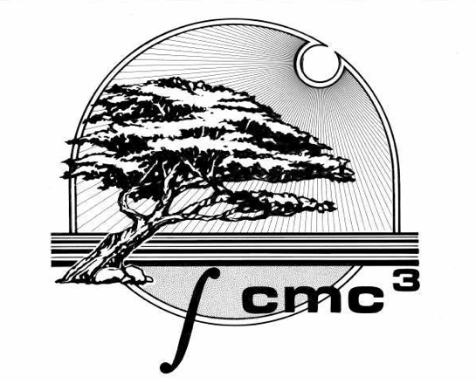
CMC³ 43rd Annual Conference, Monterey, CA

December 11 – 12, 2015
Mini-Program
Hyatt Regency Monterey
https://resweb.passkey.com/go/2015CMC3
Near the intersection of Aguajito Rd. and Mark Thomas Dr. Monterey, CA 93940 (888-421-1442)

Professional Development: Improve Student Success
in Community College Mathematics and Statistics

FRIDAY DECEMBER 11, 2015
Time | Event
See the website (www.cmc3.org) for information about pre-conference activities including a Pathways Reception (3:30 – 6:30 pm – RSVP required).
4:30 – 6:30 pm | Registration – Regency Ballroom Foyer
7:00 – 8:00 pm | Dessert Reception with Coffee, Tea and Sweets!
8:00 – 9:00 pm | IGNITE! Fast, fun talks!
9:00 – 11:59 pm | "Game Night" hosted by Pearson Higher Education

Take advantage of our free shuttle service to downtown Friday (9 pm – 1 am) and Saturday (6 pm – 10 pm).

SATURDAY DECEMBER 12, 2015
Time | Event
Meet at 7:30 am | Estimation Run/Walk
8:30 am – 5:30 pm | Commercial Exhibits open (closed from 1 to 2 pm)
8:15 am – 9:30 am | Registration – Regency Ballroom Foyer
9:30 am – 4:00 pm | Student Posters on Display
9:00 am – 5:00 pm | General Sessions
11:45 am – 12:45 pm | Buffet Luncheon
12:45 pm – 2:15 pm | General Session: Poster awards, CMC³ awards and Keynote: Erica Flapan, “How I Developed My Teaching Style”
5:00 pm – 6:00 pm | Reception with Door Prizes

A Sample of Breakout Session Presentations: (See more details at www.cmc3.org.)
Making Sense of Solving Linear and Quadratic Equations with Mapping Diagrams, Martin Flashman, Humboldt State University | The Chaos of the Real Numbers, Tim Melvin, Santa Rosa Junior College
Flipping the Gradebook: Concept-Based Grading, Phil Smith, American River College | What's the Big Deal with BIG Data? The Rising Importance of Training New Data Scientists, Robin Donatello, Cal State University Chico
The MAA-CSPCC Study: Two-Year Colleges Findings, Helen Burn, Highline College | Best Practices in Using Social Media in the Mathematics Classroom, Howard Blumenfeld, Las Positas College

Conference Chair: Joe Conrad
joseph.conrad@solano.edu 707-864-7000 ext. 4372

Is there a new faculty person at your college?
Did you know that up to one person per college can attend for free? Check out our new conference travel grant at:

www.cmc3.org/conference/montereyConferenceGrant.html


6th Annual Monterey Student Poster Session

Calling all Students!

- $75 scholarship for first place and $25 for second place.
- Posters can involve any level of mathematics that extends the usual curricula
(no book problems!). Independent study projects or modeling problems are encouraged.
- There is no fee to enter and the student gets free student registration and free lunch*.
- Students are required to be at their poster during their assigned judging time, between 9am and 11:30am.
- Students are encouraged to prepare a 2-3 minute synopsis of their project ahead of time.

- Winners will be announced during lunch.

- Students are also asked to be available to attend lunch and answer general questions on their poster at the end of lunch from 12:30pm - 12:45pm.
- A submission form is available on our website www.cmc3.org.
Submissions will be accepted until Tuesday November 24, 2015.
- Requirements: For a student to submit a poster, he or she
- should be a current community college student for Fall 2015,
- have a current CMC³ faculty member who will attend the conference and be their sponsor,
- provide an easel to display their work, and
- must be able to attend the conference.

Calling all Faculty: Interested in being a student poster judge?
Please contact Rebecca Fouquette at rebecca.russ@gmail.com for more information.

*Up to 2 free student lunches per poster without prior approval.

