DAVID ELLENBOGEN 45 BOREDOM BUSTERS Monterey, CA 12/14/13
pianomath@gmail.com

Make it Funny (Laugh of the day)

Meaningful Math Jokes

What math is about (best if used near the start of the semester): An English professor, a sociology professor and math professor are enlisted for a psychology experiment. First, the English prof is led into an empty room and finds a trashcan on fire, with a bucket of water next to it. The professor walks over, picks up the bucket and douses the fire. The experiment is set up again, and the sociologist walks over, picks up the bucket of water and douses the fire. Again the experiment is set up, and the mathematician enters the room, picks up the bucket and douses the fire.
The experiment is then repeated, but this time the bucket of water is in the corner of the room. The English prof enters the room, takes the bucket of water, walks over and douses the fire. The situation is set up again, and now the sociologist enters the room, gets the bucket of water, walks over, and douses the fire. Finally, the situation is set up again, but now the mathematician walks over, takes the bucket of water, walks over to the trashcan, and sets the bucket down next to the trashcan.
Puzzled, the psychologist asks the mathematician, why the fire wasn’t doused. To which the mathematician replies “Once I turned it into a problem that I had solved before, I lost interest.”
For classroom discussion: What was the sex of the mathematician? (followed by, why did most of the students picture the mathematician as male?)

What math is about: An economist, a logician, and a mathematician are on a train crossing into Vermont and they see a brown cow standing in a field from the window of the train (and the cow is standing parallel to the train).
And the economist says, "Look, the cows in Vermont are brown."
And the logician says, "No. There are cows in Vermont and at least one of them is brown."
And the mathematician says, "No. There is at least one cow in Vermont, of which at least one side appears to be brown."

For discussion: What is the sex of the mathematician this time, having heard the previous joke? (adapted from http://www.angrybearblog.com/2005/09/economist-logician-and
mathematician.html )

How math is learned. A martial arts student went to his teacher and said earnestly, "I am devoted to studying your martial system. How long will it take me to master it?"
The teacher's reply was casual, "Ten years."
Impatiently, the student answered, "But I want to master it faster than that. I will work very hard. I will practice everyday, ten or more hours a day if I have to. How long will it take then?"
The teacher thought for a moment, "20 years."
(from http://goto.bilkent.edu.tr/gunes/ZEN/zenstories.htm )
How math is learned, alternate version. An aspiring Samurai sword maker, troubled by how difficult he was finding the craft tells his Sensai that he’s practiced for an hour and still can’t make a proper sword. The master replies that the student hasn’t practiced long enough. The next day the student complains that he’s practiced for 4 more hours and still can’t make a proper sword. “You haven’t practiced long enough” says the Sensai. The following week the student appears and proudly announces that he can now make a proper sword. “And how long did it take?” asked the master. The student replies “I don’t know”.

To all who believe there is only one right answer: A young man being interviewed for entrance to Cambridge to study physics was asked the following question: How would you measure the height of a skyscraper using a barometer?
The candidate replied as follows: Take a very long piece of string. Tie one end of it to the barometer. Keeping hold of the other end, dangle the barometer off the roof of the skyscraper until it reaches the ground. Then the length of the string plus the length of the barometer equals the height of the skyscraper. The interviewing tutor did not accept the answer, but the candidate appealed the decision on the grounds that his answer, while perhaps unorthodox, was undeniably correct. A visiting professor was asked to arbitrate. She gave the candidate five minutes to reply to the same question again. The young candidate was silent for three minutes. The professor warned that time was running out. "The problem is," said the candidate, "I've thought of several possible answers, but can't decide which is best." "How so?" asked the professor. "Well," said the candidate, "You could take the barometer to the roof of the building and drop it, using a stopwatch to measure the time the barometer took to reach the ground. If this t is time, and the acceleration due to gravity is g, then the height of the building would be gt²/2. But then you've got an ex-barometer."
“If the sun is shining, you could measure the barometer, the length of its shadow, and the length of the skyscraper's shadow. Then it's just a matter of proportional arithmetic to work out the height of the skyscraper.
"If you want to be highly scientific you could tie a piece of string to the barometer and make it a pendulum, first on the roof and then on the ground. Then you could work out the acceleration due to gravity on the roof and on the ground from the period of its oscillation. From this difference you can determine the height of the building.
"Or you could walk up the stairs with the barometer and a pencil, marking off lengths of the barometer as you go. Adding them up at the end."
"If you want to be boring you could measure the air pressure on the roof and at ground level, convert millibars to meters and get the height of the skyscraper from that.”
"But in the end the best method would probably be to knock on the janitor's door and say, `Look; if you tell me how tall this building is, I'll give you this lovely new barometer.'"(from http://www.netjeff.com/humor/item.cgi?file=barometer )

Silly Math Jokes:

* Why is 6 afraid? Because seven ate nine. * What did the 0 say to the 8? “Nice belt!”
* What did W say when told that 3 Brazilian soldiers had been killed?
“How much is a Brazilian again?”
* What did a certain baseball player reply when asked whether
he wanted his pizza cut into six or eight slices? “Better just do six, I could never eat eight”.
* If 6 is a whole number and 9 is a whole number, is 8 a two-hole number?

Proof that a lazy dog is a piece of paper:
A lazy dog is a slow pup.
A slope up is an inclined plane.
An ink-lined plane is a piece of paper.
QED.

For Students Studying Signed Numbers (as well as more advanced students)
A physicist, a biologist and a mathematician are sitting at a street café, watching people entering and leaving the house on the other side of the street. First they see two people entering the house. Time passes. After a while they notice three people leaving the house. The physicist says, "The measurement wasn't accurate." The biologist says, "They must have reproduced." The mathematician says, "If one more person enters the house then it will be empty." (source: http://en.wikipedia.org/wiki/Mathematical_joke )

A museum visitor, examining a mastodon fossil, asks a museum employee how old it was. "That fossil is 13,801 years, one month and 23 days old," the employee replied. "How can you know it that precisely?" she asks. "Well, the report that came out back in September of last year stated that the fossil was 13,800 years old. And that was one year, one month and 23 days ago."

For Finite Math Classes
There are only 10 types of people in this world: those who understand binary and those who don’t. (source: http://en.wikipedia.org/wiki/Mathematical_joke)

There are three types of people in this world: those who can count and those who can’t.

Do you see the three errers in this sentense?

Calculus specific jokes
A certain math professor, with a certain amount of abuse of notation, once wrote the following equation, befuddled as to why the class erupted in laughter:
∫ e ^{x} = f ( u ^{n} )

Professors Mumble and Grumble are going out for lunch. In their booth at the diner, Prof Grumble bemoans the sorry state of math in the US. Ever the optimist, Prof Mumble won’t hear of it. The professors agree to a wager: They will ask the waitress if she knows what the integral of x, dx is. If she answers correctly, Prof Grumble will pay for lunch, otherwise, Prof Mumble will pay. A few minute later, Prof Grumble goes to the restroom. Prof Mumble then slips the waitress $5 and asks her to answer “x-squared over 2” when they ask her a question. Professor Grumble returns to the table, and a short while later, when their lunch arrives, he asks the waitress what the integral of x, dx is. “Why that would be x-squared over 2” she declares. As Prof Mumble gloats and the waitress returns to the kitchen, she calls out over her shoulder: “Plus C”.

Shortest calculus joke ever: Let ϵ = 0 …

How many points do you take off for a student stating that
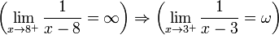
(Source: http://en.wikipedia.org/wiki/Mathematical_joke)

Funny Mistakes for Faculty to Examine (from “F in Exams, The Very Best Totally Wrong Test Answers” by Richard Benson)

Real life problem: Change 7/8 to a decimal.
Real life answer: 7.8

Real life problem: Write two hundred thousand in figures.
Real life answer: Two hundred thousand in figures.

Real life problem: Expand 2(x + y)
Real life answer: 2(x + y)
2(x + y)
2(x + y)

Get Students Engaged

Elementary Algebra through Calculus. Use “yoga” math to graph translations. Students stand with arms extended. Their arms represent the x-axis and their legs, torso, and head represent the y-axis. Graph y = x by moving arms to a 45 degree angle. Graph y = x +1 by repeating this and standing on tip toes. Graph y = x² using arms overhead in a U shape. Then graph y = x² + 1, y = (x - 3)² etc. as well as all the translations of other important functions.

Basic Graphing and Finite Math. Display a coordinate system extending from -10 to 10 both horizontally and vertically. Secretly write down the coordinates of a point using integer coefficients. Give students 10 questions to determine the coordinates, in which they are limited to asking Yes/No type questions. Wisely used, the coordinates can always be determined this way. However, squandering just one question can result in guessing at the end. Shade those regions that students have eliminated (or preserved), and require students to ask questions in proper mathematical form: ie. “Is the x-coordinate greater than 0?”, or “is the point above the line y = x ?” etc. In Finite Math, students can examine how powers of 2 play into this.

Statistics One doesn’t need to be a rocket scientist to notice some correlations.
(from “Representation and Misrepresentation: Tufte and the Morton Thiokol Engineers and the Challenger” by Robison, W et al.)
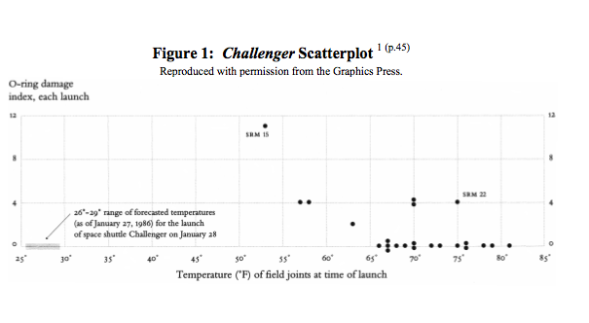
Finite Math and Statistics. Do the birthday problem, assuming you have at least 23 students in your classroom, and wager a soda or cup of coffee that “At least two people in the room share the same birthday”.
If possible, do before a holiday and suggest that students attending a large feast try it there.

Basic Math through Intermediate Algebra. To motivate order of operation and the significant advantage that written math has over the English language, examine the sentence

Jean said Paul is tall.

Without punctuation, can you tell who is tall?

Elementary, Intermediate, or College Algebra
Introduce the commutative and associative properties of addition (or a discussion of the sum of a series) by relating the story of the young Frederic Gauss: Assigned (perhaps as punishment) the task of calculating the sum of the numbers from 1 to 100, Gauss rapidly answered 5050. How did he do it?
How might we calculate 1 + 2 + 3 + + 1000?

Intermediate Algebra and Finite Math. Try filling in a Venn diagram that students can have fun with. Be sure to fill in every region. The completed diagram can also be used to illustrate the inclusion/exclusion principle. (based on an article in the Village Voice from the 1980’s)

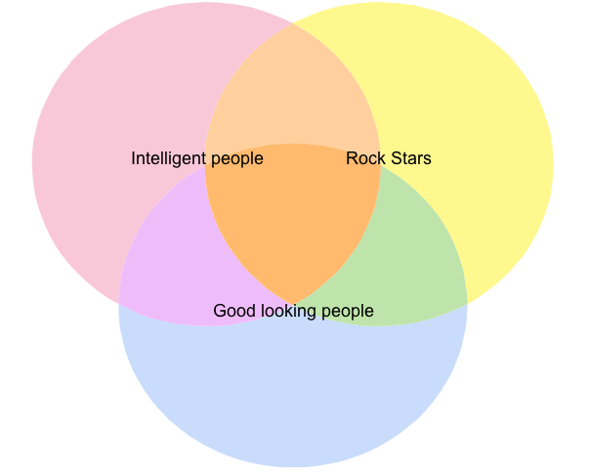

Make it Current

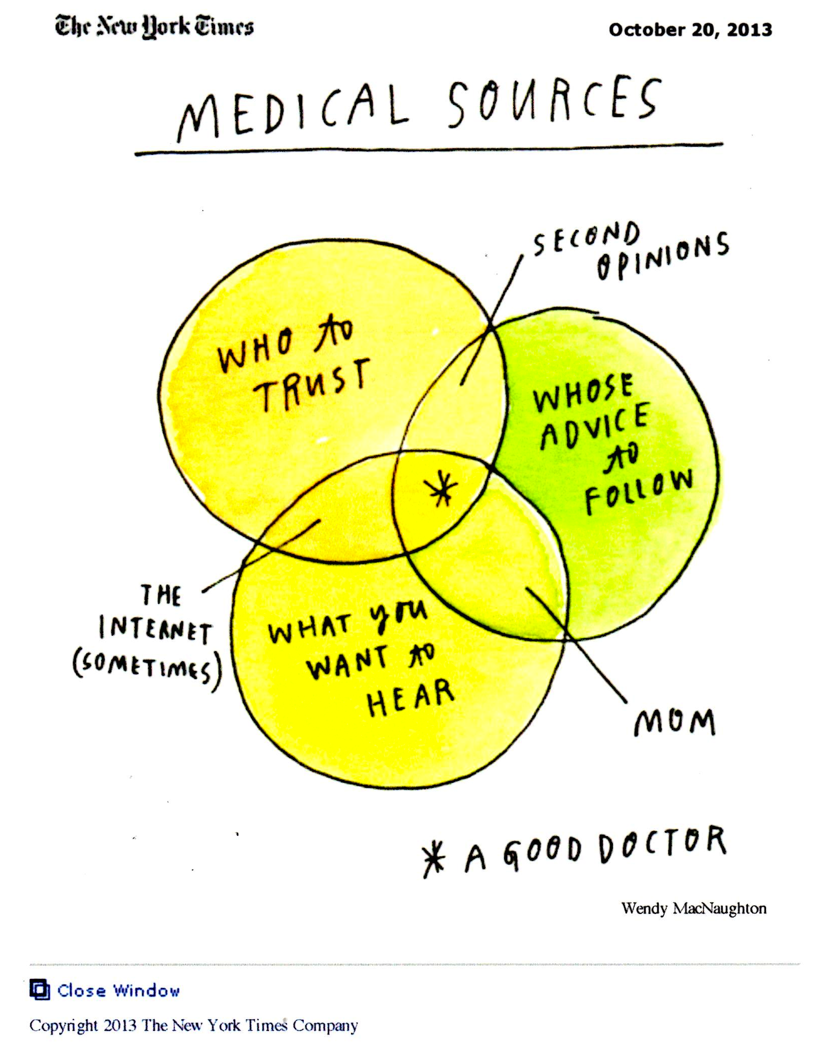

From The Daily Good, December 9, 2013

Bertrand Russell:
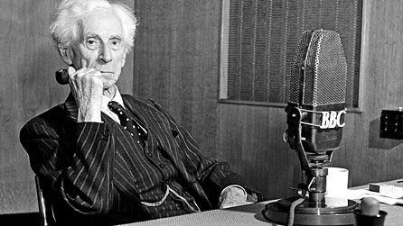
Perhaps the essence of the Liberal outlook could be summed up in a new decalogue, not intended to replace the old one but only to supplement it. The Ten Commandments that, as a teacher, I should wish to promulgate, might be set forth as follows:
1. Do not feel absolutely certain of anything.
2. Do not think it worthwhile to proceed by concealing evidence, for the evidence is sure to come to light.
3. Never try to discourage thinking for you are sure to succeed.
4. When you meet with opposition, even if it should be from your husband or your children, endeavor to overcome it by argument and not by authority, for a victory dependent upon authority is unreal and illusory.
5. Have no respect for the authority of others, for there are always contrary authorities to be found.
6. Do not use power to suppress opinions you think pernicious, for if you do the opinions will suppress you.
7. Do not fear to be eccentric in opinion, for every opinion now accepted was once eccentric.
8. Find more pleasure in intelligent dissent than in passive agreement, for, if you value intelligence as you should, the former implies a deeper agreement than the latter.
9. Be scrupulously truthful, even if the truth is inconvenient, for it is more inconvenient when you try to conceal it.
10. Do not feel envious of the happiness of those who live in a fool’s paradise, for only a fool will think that it is happiness.
Thanks,
Will
- See more at: http://m.dailygood.org/story/591/bertrand-russell-s-10-commandments-of-teaching-maria-popova/view.php?op=print&qid=5737#sthash.xErgcwQI.dpuf

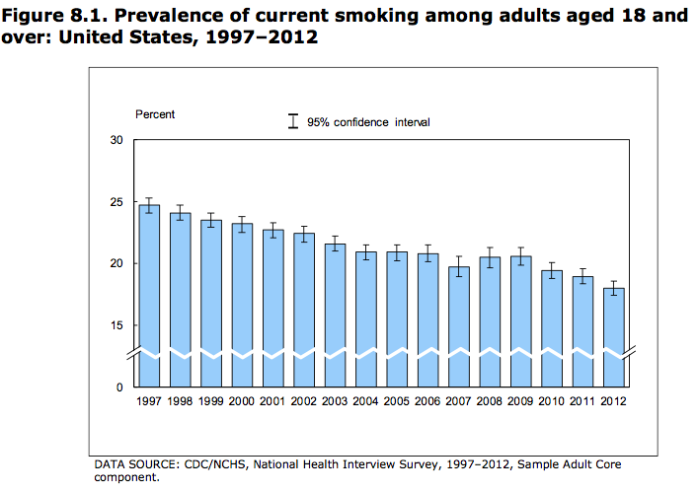

New York Times; October 20, 2011

A Big-Game Hunt by Early North Americans

By SINDYA N. BHANOO
For many years, it was thought that the Clovis people were the first humans to populate North America, about 13,000 years ago. But recently, evidence has suggested that other settlers arrived earlier, and a new study lends support to that hypothesis. The study, in the journal Science, finds that a mastodon rib with a bone point lodged in it dates back 13,800 years. “It’s the first hunting weapon found pre-Clovis,” said the lead author, Michael R. Waters, an archaeologist at Texas A&M University. “These people were hunting mastodons.” The fossils had been discovered in the late 1970s at a dig known as the Manis site, near Sequim, Wash., by Carl Gustafson, an archaeologist at Washington State University. At the time, Dr. Gustafson proposed that the skeleton was about 14,000 years old and that hunters had killed the mastodon with a bone point. His theory was questioned by other scientists. But carbon dating technology has improved since then, and Dr. Waters and his colleagues — including Dr. Gustafson — were able to use mass spectrometry to date the rib, the bone point and tusks that were found at the site.

Give of Yourself Personally

Introduce yourself. The first day of class give a five-minute autobiography of yourself. Include whatever details you wish:
Where you grew up,
Where you went to college,
Any siblings or kids you have,
What jobs you held,
What hobbies you have, etc.

Listen to their horror stories
Take time the first day of a Basic Skills or Prealgebra course to have students share math horror stories. Students are always relieved to find that they are not alone. The humiliation, scares, and embarrassment to which many students were subjected (by teachers, parents, and siblings) are eye opening. Getting these stories out in the open can clear the way for learning to take place. One way to start out is to announce: “OK. Let’s hear them.” Students will raise eyebrows until you continue with “The horror stories. I have a friend whose teacher once held up his paper and asked the class to see how poorly Bob did on the test”. Usually there are a number of students who will pick up on that.

Bring in Props
Show students samples of the videos and tutorials that come with their text. It is better to actually show a snippet of a video than to tell students seven times that they are up in cyberspace waiting to be downloaded.
Bring in Witnesses
Record bring into your classroom, students who took your course in a previous semester. Have them testify to approaches that worked (or didn’t work) for them. Consider leaving the classroom to improve candor. Make sure the student(s) offer at least three pieces of advise. Consider recording ‘parting messages’ from students finishing up a course and then playing the video on the first day of class, if you don’t actually have past students stop by to ‘testify’.

Bring in Tutors
Introduce students to a pair of tutors (one female and one male, if possible) that the students might meet if they come to the college math lab or learning lab for help. It is easier for students to take the plunge and seek tutoring, if they know in advance that the tutor is an approachable person. If possible, ask the visiting tutors to roam the classroom with you as students try a couple of in-class problems.

Interview Two Students per week
Ask each interviewee a bit about who they are and how they came to be in your class. Do they have kids? Ask them each for one bit of information about themself that people might be surprised to know. Hobbies? Talents? Sports? Academic interests?

Make your students feel important
What student doesn’t enjoy seeing his or her work projected on a screen with “Nicely done!” written beside it. Consider displaying creative or nicely organized solutions that appear as student work on a quiz, test, or hand-in assignment. One popular assignment in Finite Math or Statistics can be for students to create (and solve, correctly) their own problem that requires use of the Multiplication Rule -- or permutations or combinations. Then, turn the best or most interesting of these student creations into transparencies or scans for the class to view.

Raffle off a prize
Announce in advance an in-class raffle of a prize (or prizes) valued at $100 or more, but you must be present to win. The prize, not announced in advance, is a desk copy of a text that you no longer need. If possible, offer that student a text that may be useful in the next course in which she or he is about to enroll. If you award two or more prizes, students can calculate their probability of winning at least one prize.

Share ways in which math has been real in your life (and feel free to use these from my life).
Nuclear Power. In the late 1980’s Vermont Yankee Nuclear Power plant was requested by the governor to determine, among other things, the likelihood of a meltdown. At a hearing in which representatives of the plant revealed the tiny number resulting from their calculations, a certain math professor in the audience (yours truly) objected that the probabilities that they were multiplying together were not indeed those of independent events. For example, the probability of cooling systems 1 and 2 both failing is not the product of the two separate probabilities, since the likelihood of system 2 failing, given that system 1 has failed is greater than the probability of system 2 failing by itself (suppose, for instance, an earthquake or some other disaster has struck and knocked out system 1). A member of the state nuclear oversight panel, with a degree in Physics, agreed with the audience member and sent the nuclear plant back to do more homework.

Sports betting. A certain high school student (me), bored to tears by an incompetent teacher, took more interest in the odds that were given by the local bookies on the so-called “Football Tickets” that he and his friends played each week. For $1, one could select four games in which they would predict the winning team, after the point spread was considered. To win $10 for a $1 bet, all four selections needed to be correct, otherwise the bookie won. Realizing that this was tantamount to predicting the outcome of four coin tosses, this student calculated that a ‘fair’ payback would be $16 for the $1 bet. With this calculation in hand, the student began collecting the bets himself, making a small bit of money from his classmates (despite the occasional payout). He retired before any knees were smashed due to elbowing in on organized crime.

Provide Puzzles for students to take home after a test/quiz.
All students need to experience success and what better way for them to do so than on a puzzle that requires little more than logic and perseverance? Of course, it is not enough for the student to simply ‘solve’ the puzzle. They should explain, on paper, why their solution works. A few extra points makes little difference in an overall average, but those points may be just the incentive some weaker students need. They can even share this type of math with their family.

Measure Four Liters. A student has a three-liter jug and a five liter jug, and access to a sink. How can he or she use the two jugs to measure exactly four liters? (based on a puzzle from “Classroom Quickies, Book 1, Anita Harnadek, Critical Thinking Press and Software.)

Gain the King’s Favor. Three geniuses are vying for a sack of gold from a ruler who tells them: “I have three red hats and two white hats. I will blindfold you and then place three of the five hats on your heads, discarding the other two. I will then remove the blindfolds. The first of you to correctly tell me the color of the hat that is on your head, without looking at it, gets the gold.” The first genius says, “I can’t tell”. The second says likewise. The third genius, (who was blind, to boot!) correctly identifies the hat atop his/her head. What color is that third hat and how did that person know?
(based on a puzzle from “Classroom Quickies, Book 1, Anita Harnadek, Critical Thinking Press and Software.)

The beauty of trying (great when starting factoring of trinomials).
A highly intelligent census taker approaches a house. She asks the man who answers the door
"How many children do you have, and what are their ages?"
Man: "I have three children, the product of their ages is 36, the sum of their ages is equal to the address of the house next door."
The census taker walks next door, comes back and says "I need more information."
The man replies, "I have to go, my oldest child is sleeping upstairs."
Census taker: "Thank you, I now have everything I need."
How old are the children? (adapted from http://www.mathsisfun.com/census.html)

Find the Heavy Marble. A student has eight identical looking marbles, one of which is just slightly heavier than the others. The student also has access to a jeweler’s balance. What is the least number of weighings that can guarantee identifying the heavy marble? (based on a puzzle from “Classroom Quickies, Book 1, Anita Harnadek, Critical Thinking Press and Software.)

Finally, try to diffuse tension before a final exam:
The setting was allegedly Ohio State University in a huge (200 students) Calculus class.
This particular calculus teacher - not well liked - was in the habit of standing in front of the class and yelling out how much time was remaining before the end of the final exam. Busy gallivanting around the room making sure that nobody cheated and that everyone was aware of how much time remained before their misery ended, he had students stack their completed Scantron cards (use blue books if you prefer) on the podium at the front of the room.
During this particular final, one guy taking the test had just one problem with Calculus: he did poorly when rushed, and the lecturer barking out times in front of the room did nothing to help him. Desperately wanting a decent grade, he hardly flinched when the professor said, "Pencils down and place your Scantron cards in a pile at the front of the room".
Five minutes turned into ten, and ten into twenty before our friend finally put down his pencil and headed to the front of the hall to submit his final. The whole time, the professor had been sitting at the front of the room, strangely waiting for the student to complete his exam.
"What do you think you're doing?" the professor asked as the student stood in front of him about to put down his exam on the neatly stacked pile of exams. It was clear that the professor had waited only to give the student a hard time. "Turning in my exam," retorted the student confidently. "I can’t accept this," the professor gloated, "it is over twenty minutes late.”
The student smiled slyly and asked the professor "Do you know who I am?"
"What!?!" the professor roared, annoyed that the student seemed so impudent.
The student puffed out his chest and confidently repeated, "Do you know who I am?"
"There are 200 students in this class. I don’t know who you are and I don’t care if you’re the Dean’s son, you will be getting a zero on this exam!", snarled the professor.
The student looked the professor dead in the eyes and said slowly, "I’m not so sure." And with that he shoved his test neatly into the center of the stack of exams, knocked over the pile, and left. (based on http://www.jokesplace.com/joke/finalexam.html)

And there are always cartoons and comics, the best of which have educational value:

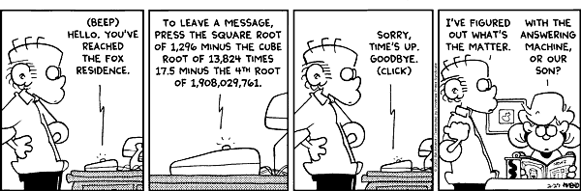

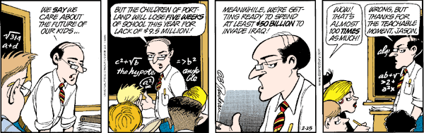

(Comics from http://math.sfsu.edu/beck/quotes.html)

